INTERNET PROGRAMMING LAB

Experiment 1: Library Management System

Aim
Search books and show library issue/return information.

Algorithm
- Start and open the page in a web browser.
- Search a sample book list and display matching results.
- Click Run Demo to execute the JavaScript function.
- Display the result on the webpage.
- Stop.

Code (save as index.html)
<!DOCTYPE html>
<html lang="en">
<head>
<meta charset="UTF-8">
<meta name="viewport" content="width=device-width, initial-scale=1.0">
<title>Library Management System</title>
<style>
body{font-family:Arial,sans-serif;max-width:760px;margin:40px auto;padding:24px;background:#f3f6fa;color:#172033}
main{background:white;padding:24px;border-radius:12px}h1{color:#155e75}button{padding:9px 16px;cursor:pointer}
</style>
</head>
<body><main><h1>Library Management System</h1><p>Search books and show library issue/return information.</p>
<button onclick="runDemo()">Run Demo</button><p id="result">Click Run Demo to display the sample result.</p></main>
<script>
function runDemo(){document.getElementById('result').textContent="Available books: HTML Basics, Java Programming, Web Technology.";}
</script></body></html>

Expected Output
Available books: HTML Basics, Java Programming, Web Technology.
Result: The page runs in a modern browser and displays the sample result when Run Demo is clicked.
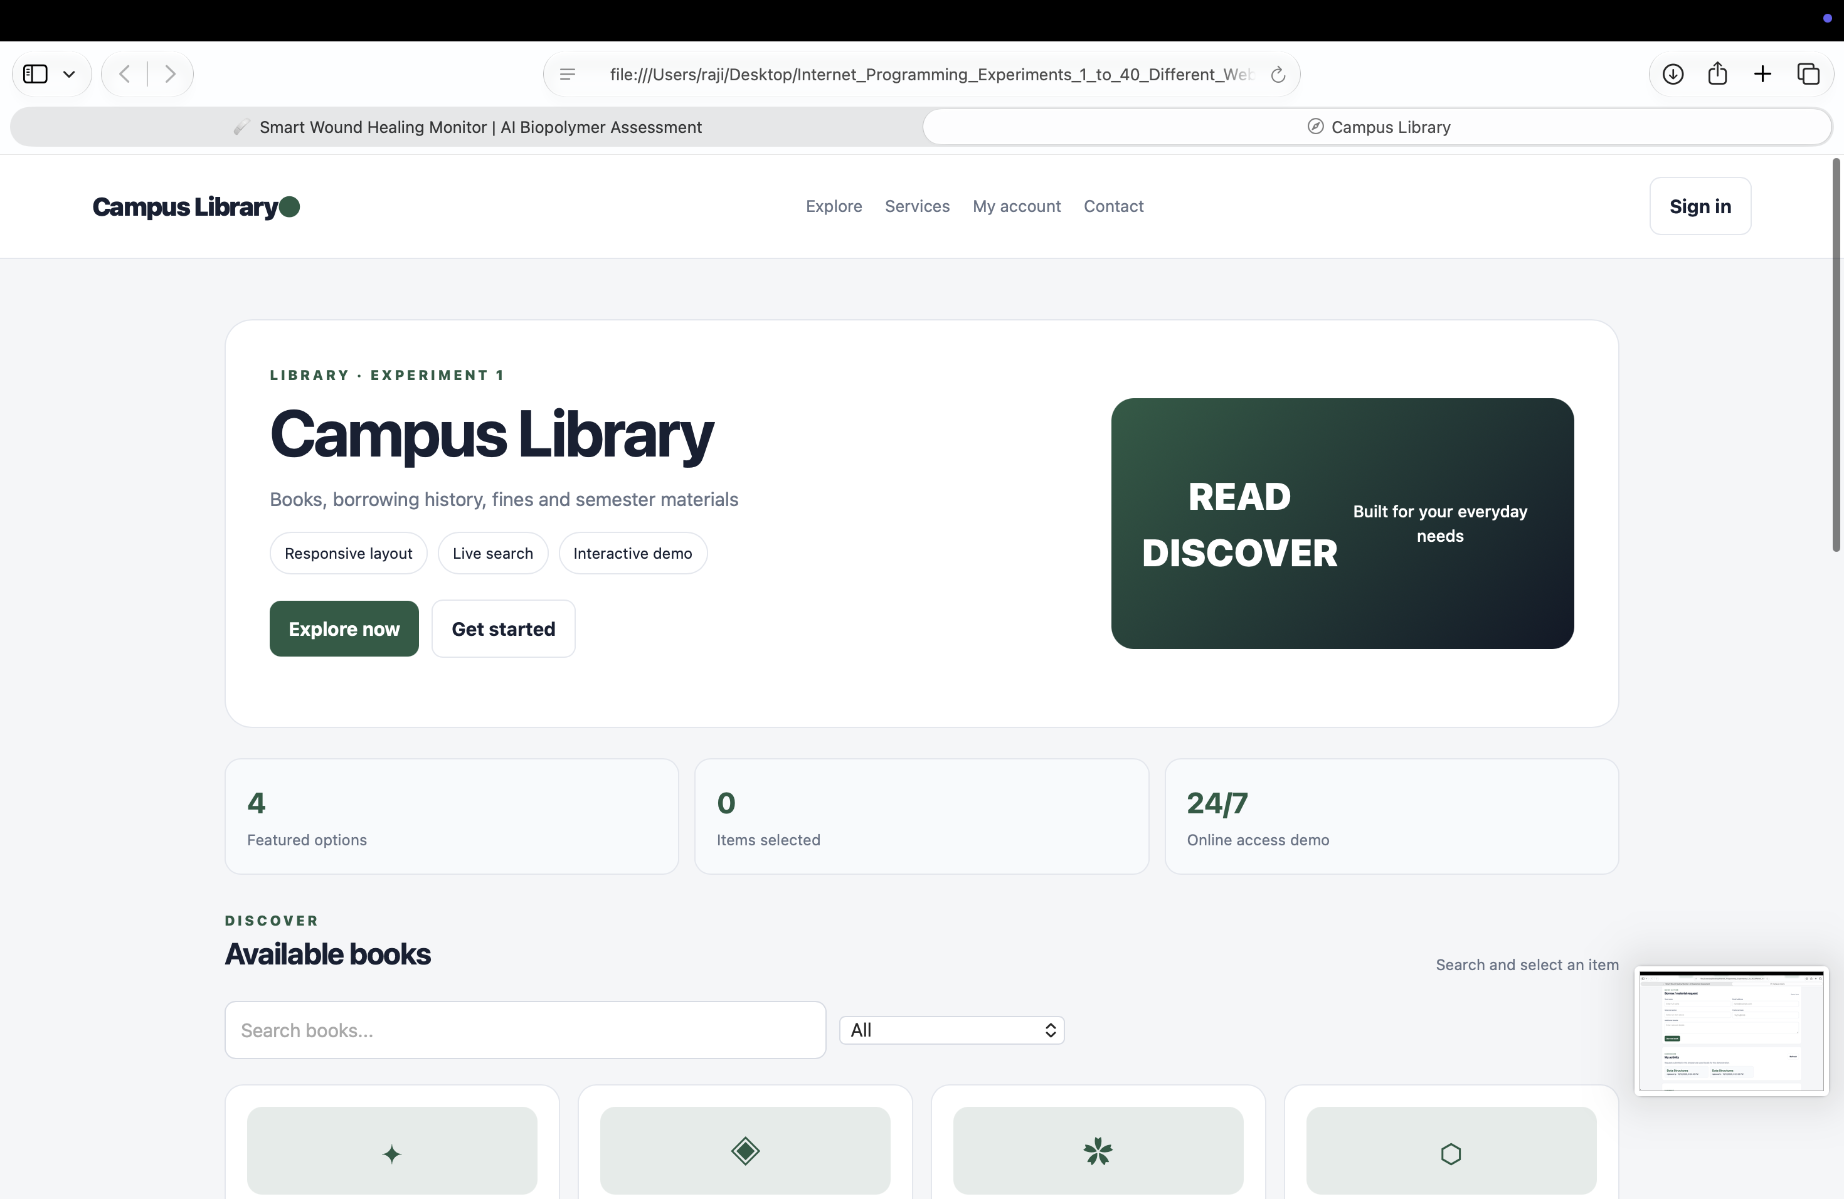
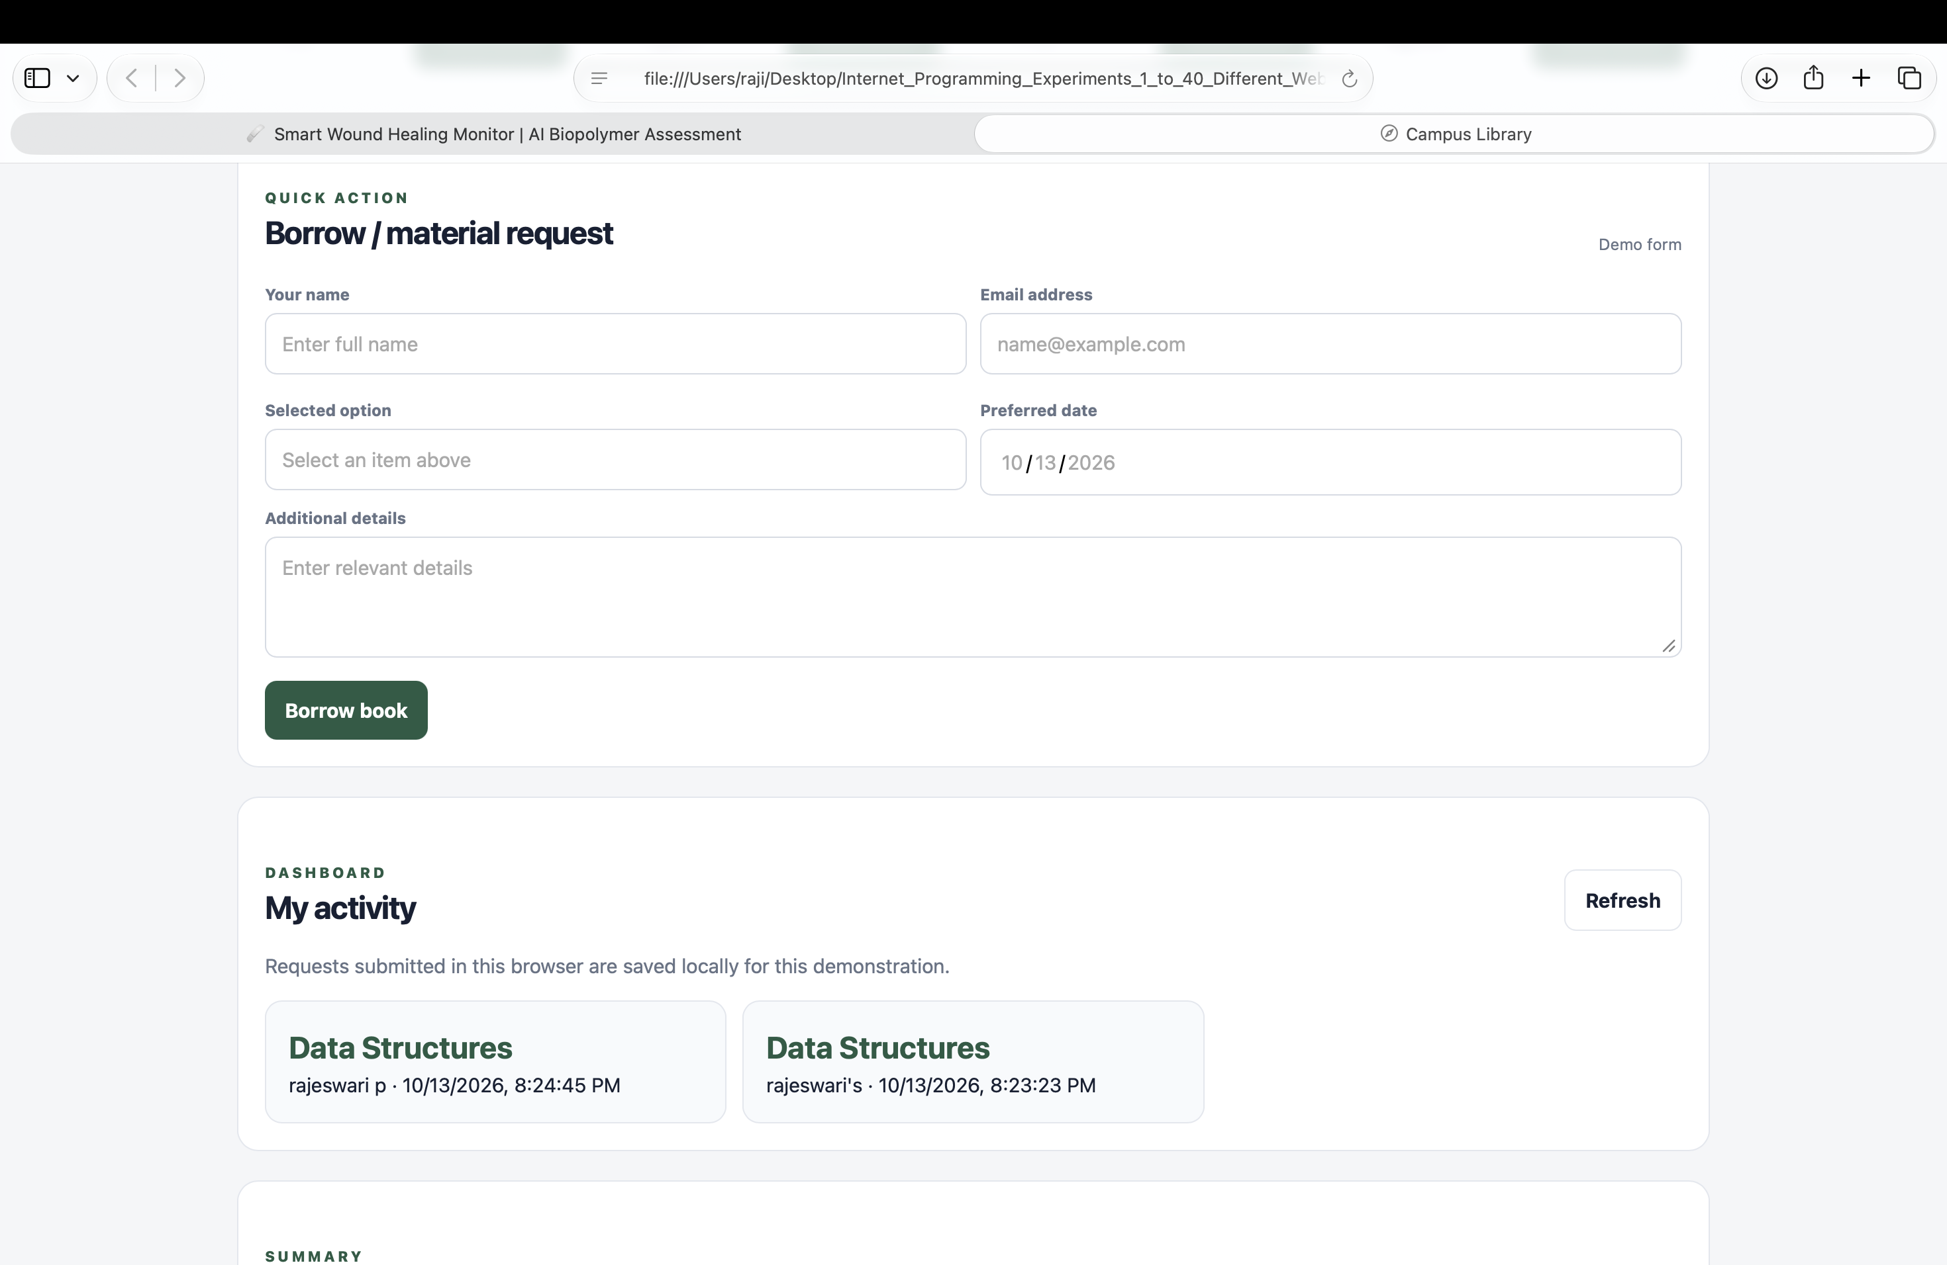

Experiment 2: Hotel Room Booking System

Aim
Create a hotel room booking interface.

Algorithm
- Start and open the page in a web browser.
- Choose a room, enter guest details, validate, and show confirmation.
- Click Run Demo to execute the JavaScript function.
- Display the result on the webpage.
- Stop.

Code (save as index.html)
<!DOCTYPE html>
<html lang="en">
<head>
<meta charset="UTF-8">
<meta name="viewport" content="width=device-width, initial-scale=1.0">
<title>Hotel Room Booking System</title>
<style>
body{font-family:Arial,sans-serif;max-width:760px;margin:40px auto;padding:24px;background:#f3f6fa;color:#172033}
main{background:white;padding:24px;border-radius:12px}h1{color:#155e75}button{padding:9px 16px;cursor:pointer}
</style>
</head>
<body><main><h1>Hotel Room Booking System</h1><p>Create a hotel room booking interface.</p>
<button onclick="runDemo()">Run Demo</button><p id="result">Click Run Demo to display the sample result.</p></main>
<script>
function runDemo(){document.getElementById('result').textContent="Booking request submitted (demo).";}
</script></body></html>

Expected Output
Booking request submitted (demo).
Result: The page runs in a modern browser and displays the sample result when Run Demo is clicked.
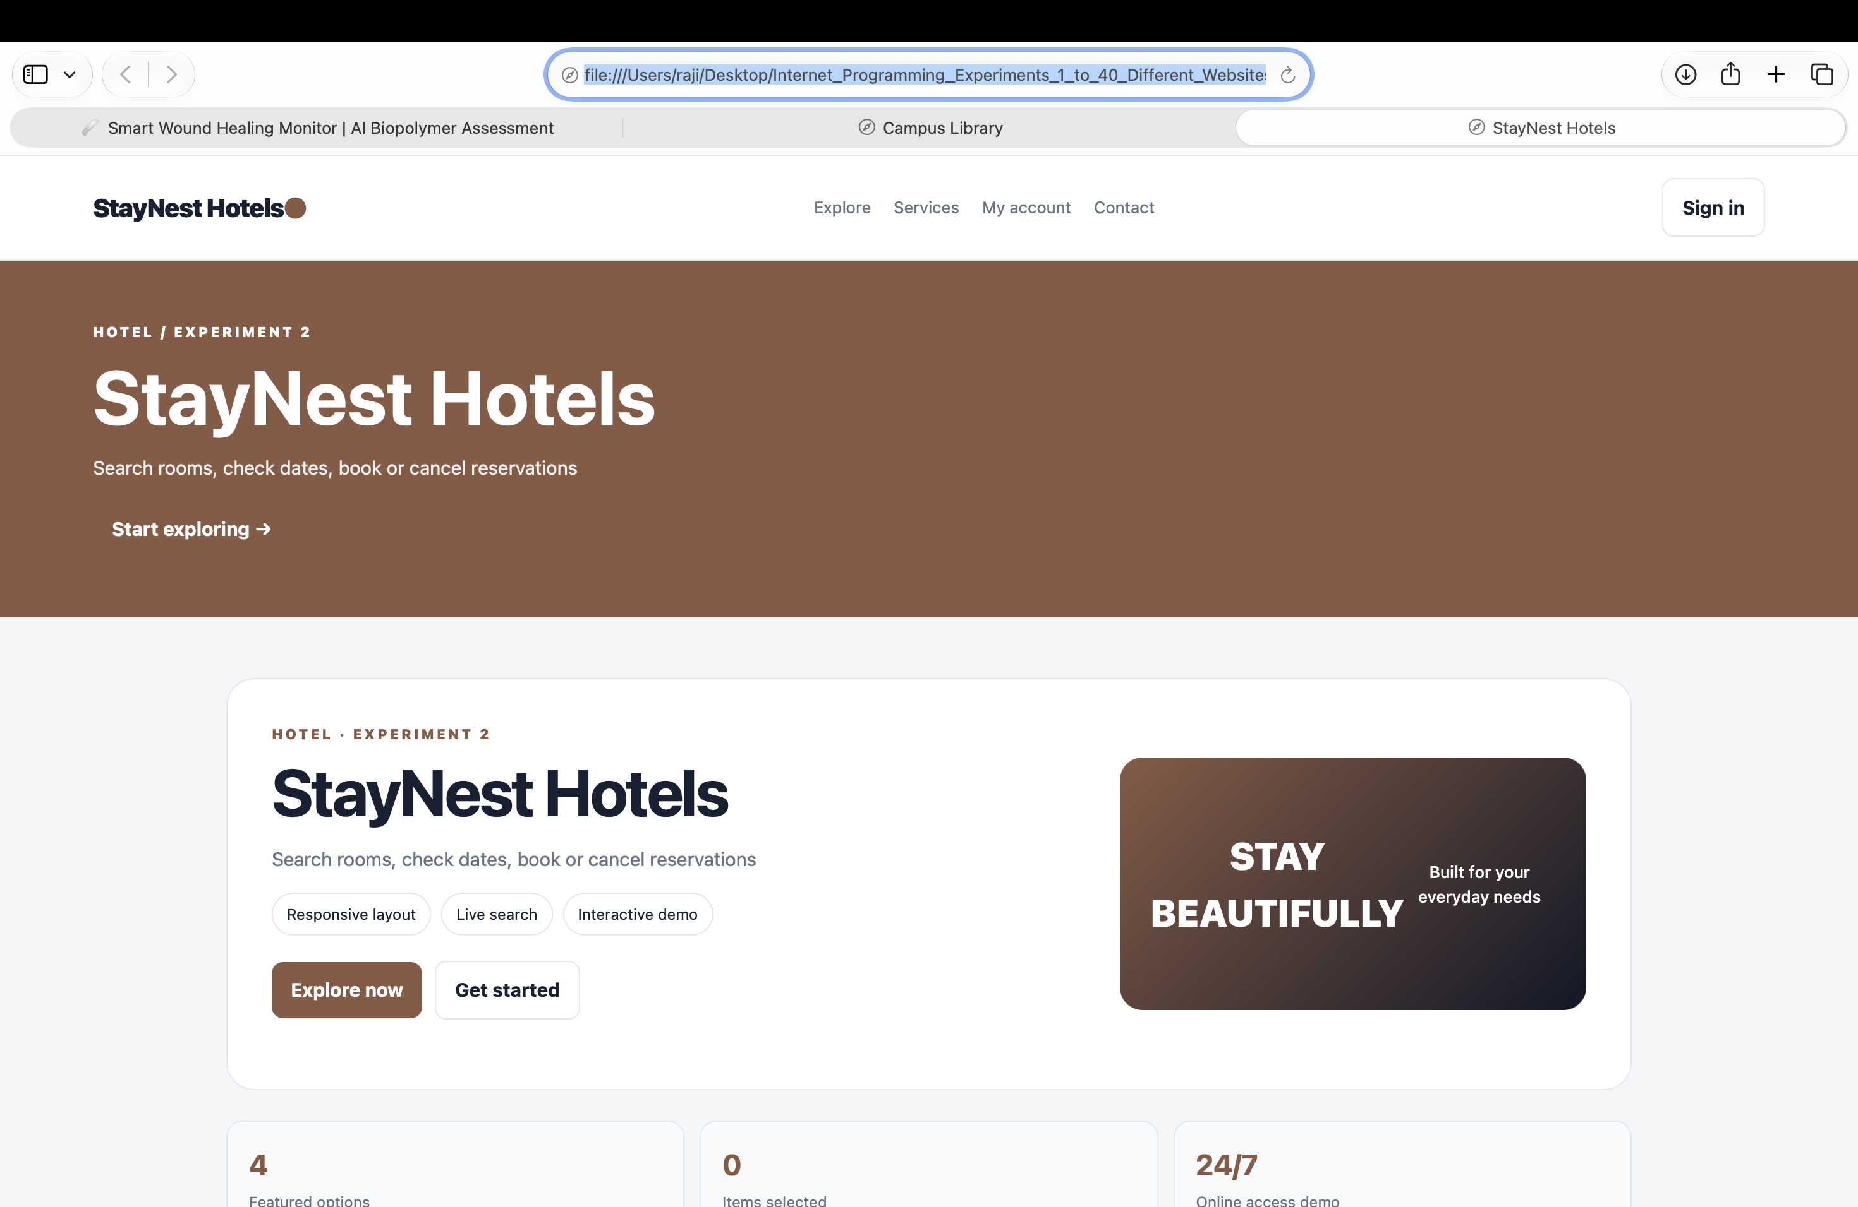
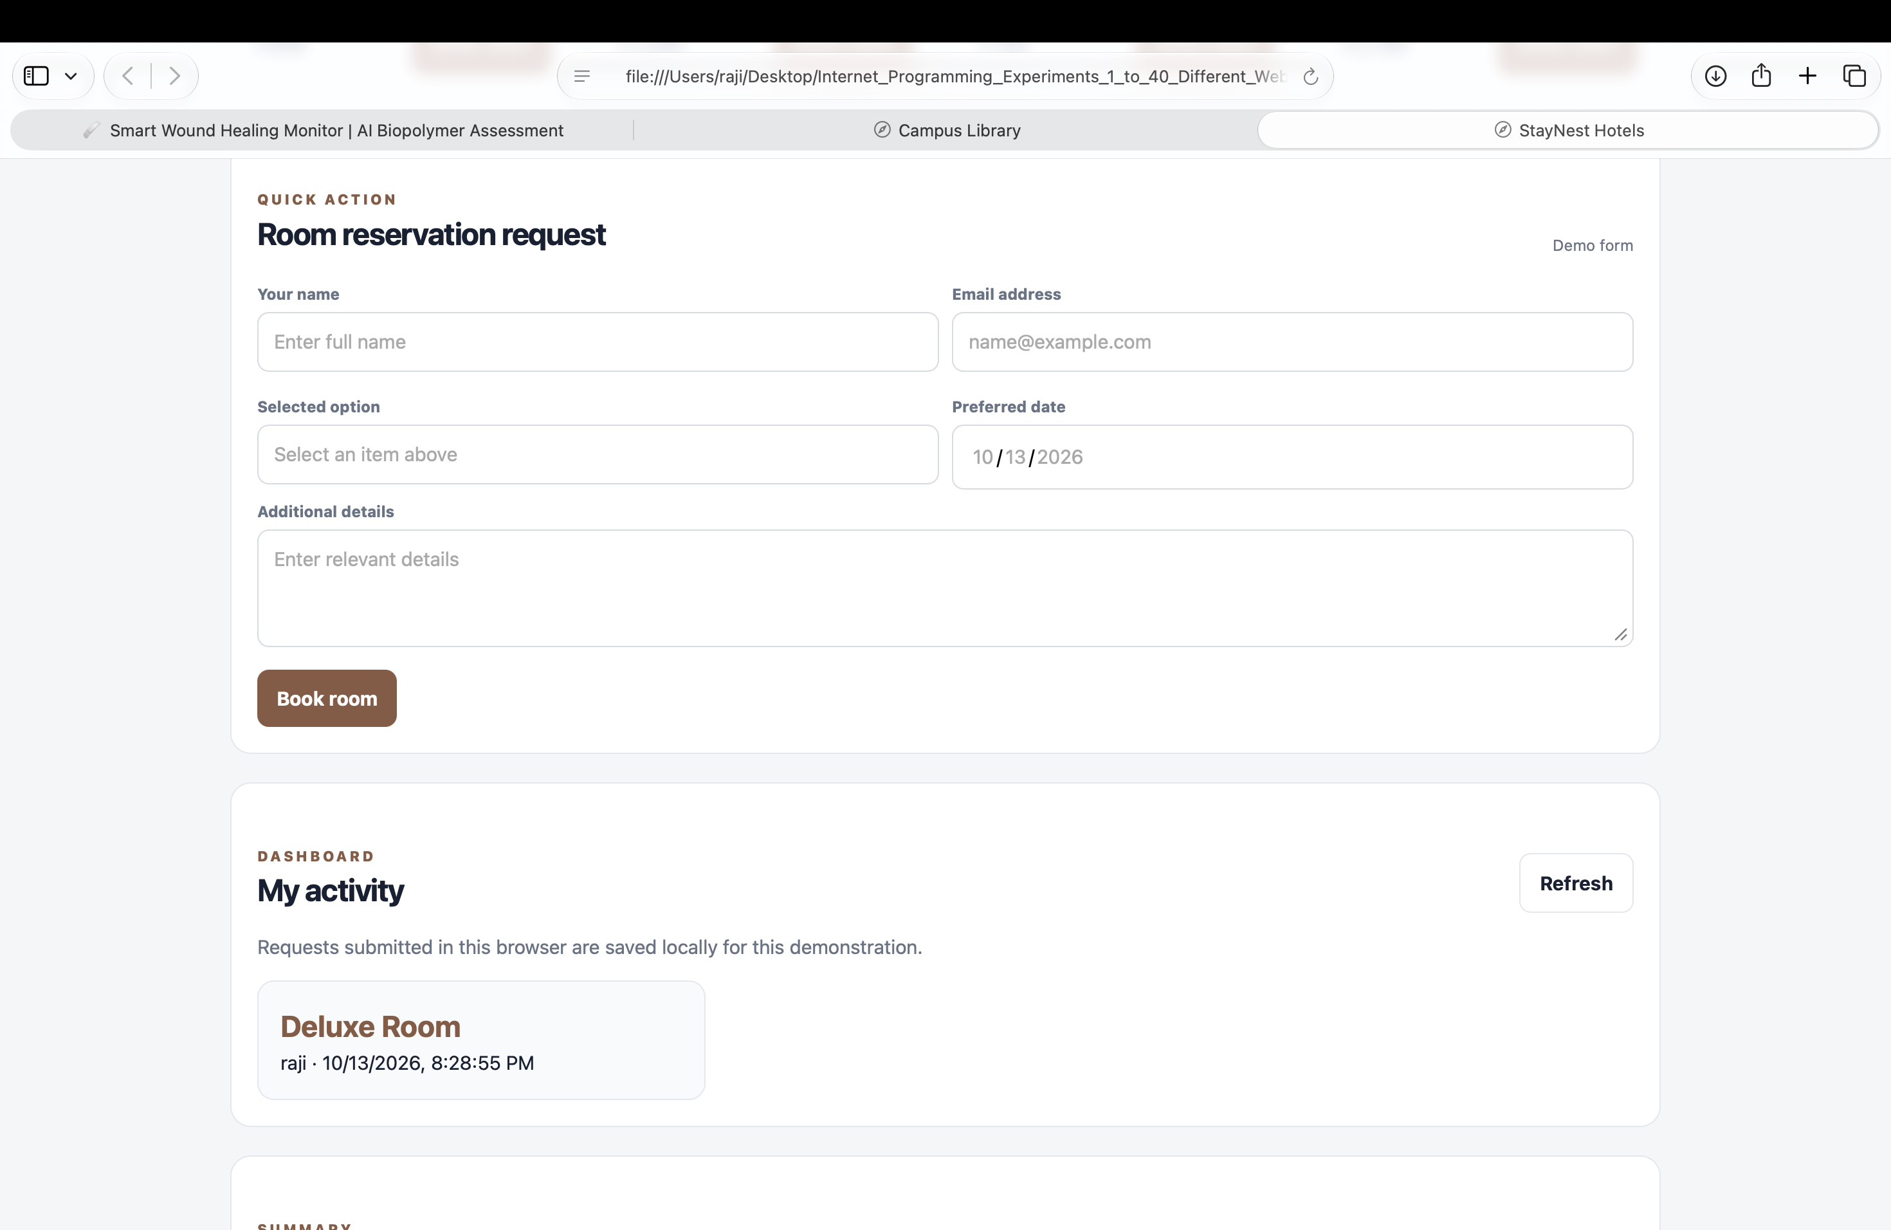

Experiment 3: Bus Ticket Booking System

Aim
Search buses and confirm a sample ticket.

Algorithm
- Start and open the page in a web browser.
- Enter route and date, display a sample bus, and show booking status.
- Click Run Demo to execute the JavaScript function.
- Display the result on the webpage.
- Stop.

Code (save as index.html)
<!DOCTYPE html>
<html lang="en">
<head>
<meta charset="UTF-8">
<meta name="viewport" content="width=device-width, initial-scale=1.0">
<title>Bus Ticket Booking System</title>
<style>
body{font-family:Arial,sans-serif;max-width:760px;margin:40px auto;padding:24px;background:#f3f6fa;color:#172033}
main{background:white;padding:24px;border-radius:12px}h1{color:#155e75}button{padding:9px 16px;cursor:pointer}
</style>
</head>
<body><main><h1>Bus Ticket Booking System</h1><p>Search buses and confirm a sample ticket.</p>
<button onclick="runDemo()">Run Demo</button><p id="result">Click Run Demo to display the sample result.</p></main>
<script>
function runDemo(){document.getElementById('result').textContent="Demo booking confirmed.";}
</script></body></html>

Expected Output
Demo booking confirmed.
Result: The page runs in a modern browser and displays the sample result when Run Demo is clicked.
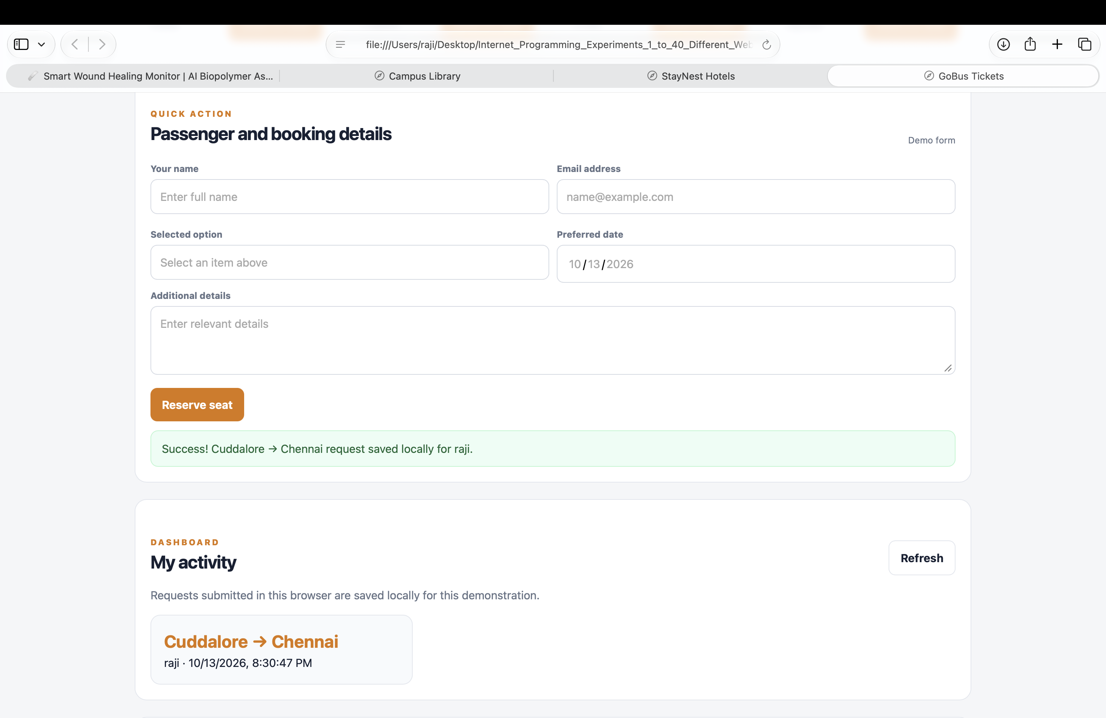

Experiment 4: Train Reservation System

Aim
Search trains and display a sample reservation.

Algorithm
- Start and open the page in a web browser.
- Enter route and journey date, select a train, and show a sample PNR.
- Click Run Demo to execute the JavaScript function.
- Display the result on the webpage.
- Stop.

Code (save as index.html)
<!DOCTYPE html>
<html lang="en">
<head>
<meta charset="UTF-8">
<meta name="viewport" content="width=device-width, initial-scale=1.0">
<title>Train Reservation System</title>
<style>
body{font-family:Arial,sans-serif;max-width:760px;margin:40px auto;padding:24px;background:#f3f6fa;color:#172033}
main{background:white;padding:24px;border-radius:12px}h1{color:#155e75}button{padding:9px 16px;cursor:pointer}
</style>
</head>
<body><main><h1>Train Reservation System</h1><p>Search trains and display a sample reservation.</p>
<button onclick="runDemo()">Run Demo</button><p id="result">Click Run Demo to display the sample result.</p></main>
<script>
function runDemo(){document.getElementById('result').textContent="PNR: DEMO12345 (sample only).";}
</script></body></html>

Expected Output
PNR: DEMO12345 (sample only).
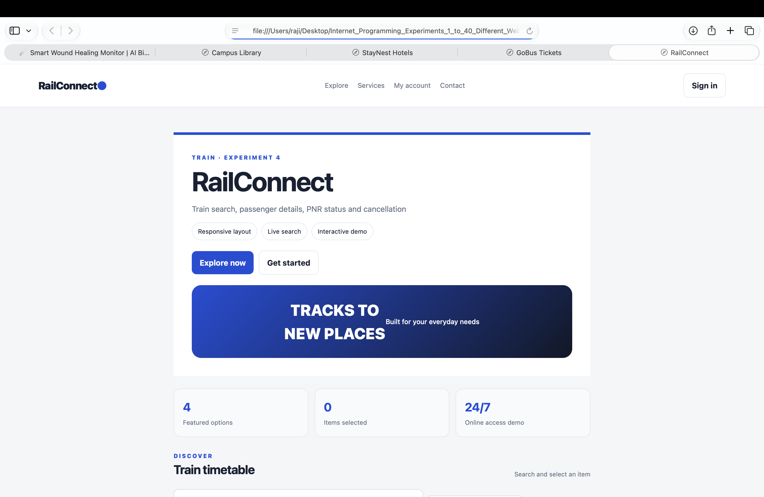
Result: The page runs in a modern browser and displays the sample result when Run Demo is clicked.

Experiment 5: Flight Reservation System

Aim
Create a flight search and ticket page.

Algorithm
- Start and open the page in a web browser.
- Enter origin, destination and date, then display a sample flight.
- Click Run Demo to execute the JavaScript function.
- Display the result on the webpage.
- Stop.

Code (save as index.html)
<!DOCTYPE html>
<html lang="en">
<head>
<meta charset="UTF-8">
<meta name="viewport" content="width=device-width, initial-scale=1.0">
<title>Flight Reservation System</title>
<style>
body{font-family:Arial,sans-serif;max-width:760px;margin:40px auto;padding:24px;background:#f3f6fa;color:#172033}
main{background:white;padding:24px;border-radius:12px}h1{color:#155e75}button{padding:9px 16px;cursor:pointer}
</style>
</head>
<body><main><h1>Flight Reservation System</h1><p>Create a flight search and ticket page.</p>
<button onclick="runDemo()">Run Demo</button><p id="result">Click Run Demo to display the sample result.</p></main>
<script>
function runDemo(){document.getElementById('result').textContent="Chennai to Delhi; ticket request confirmed (demo).";}
</script></body></html>

Expected Output
Chennai to Delhi; ticket request confirmed (demo).
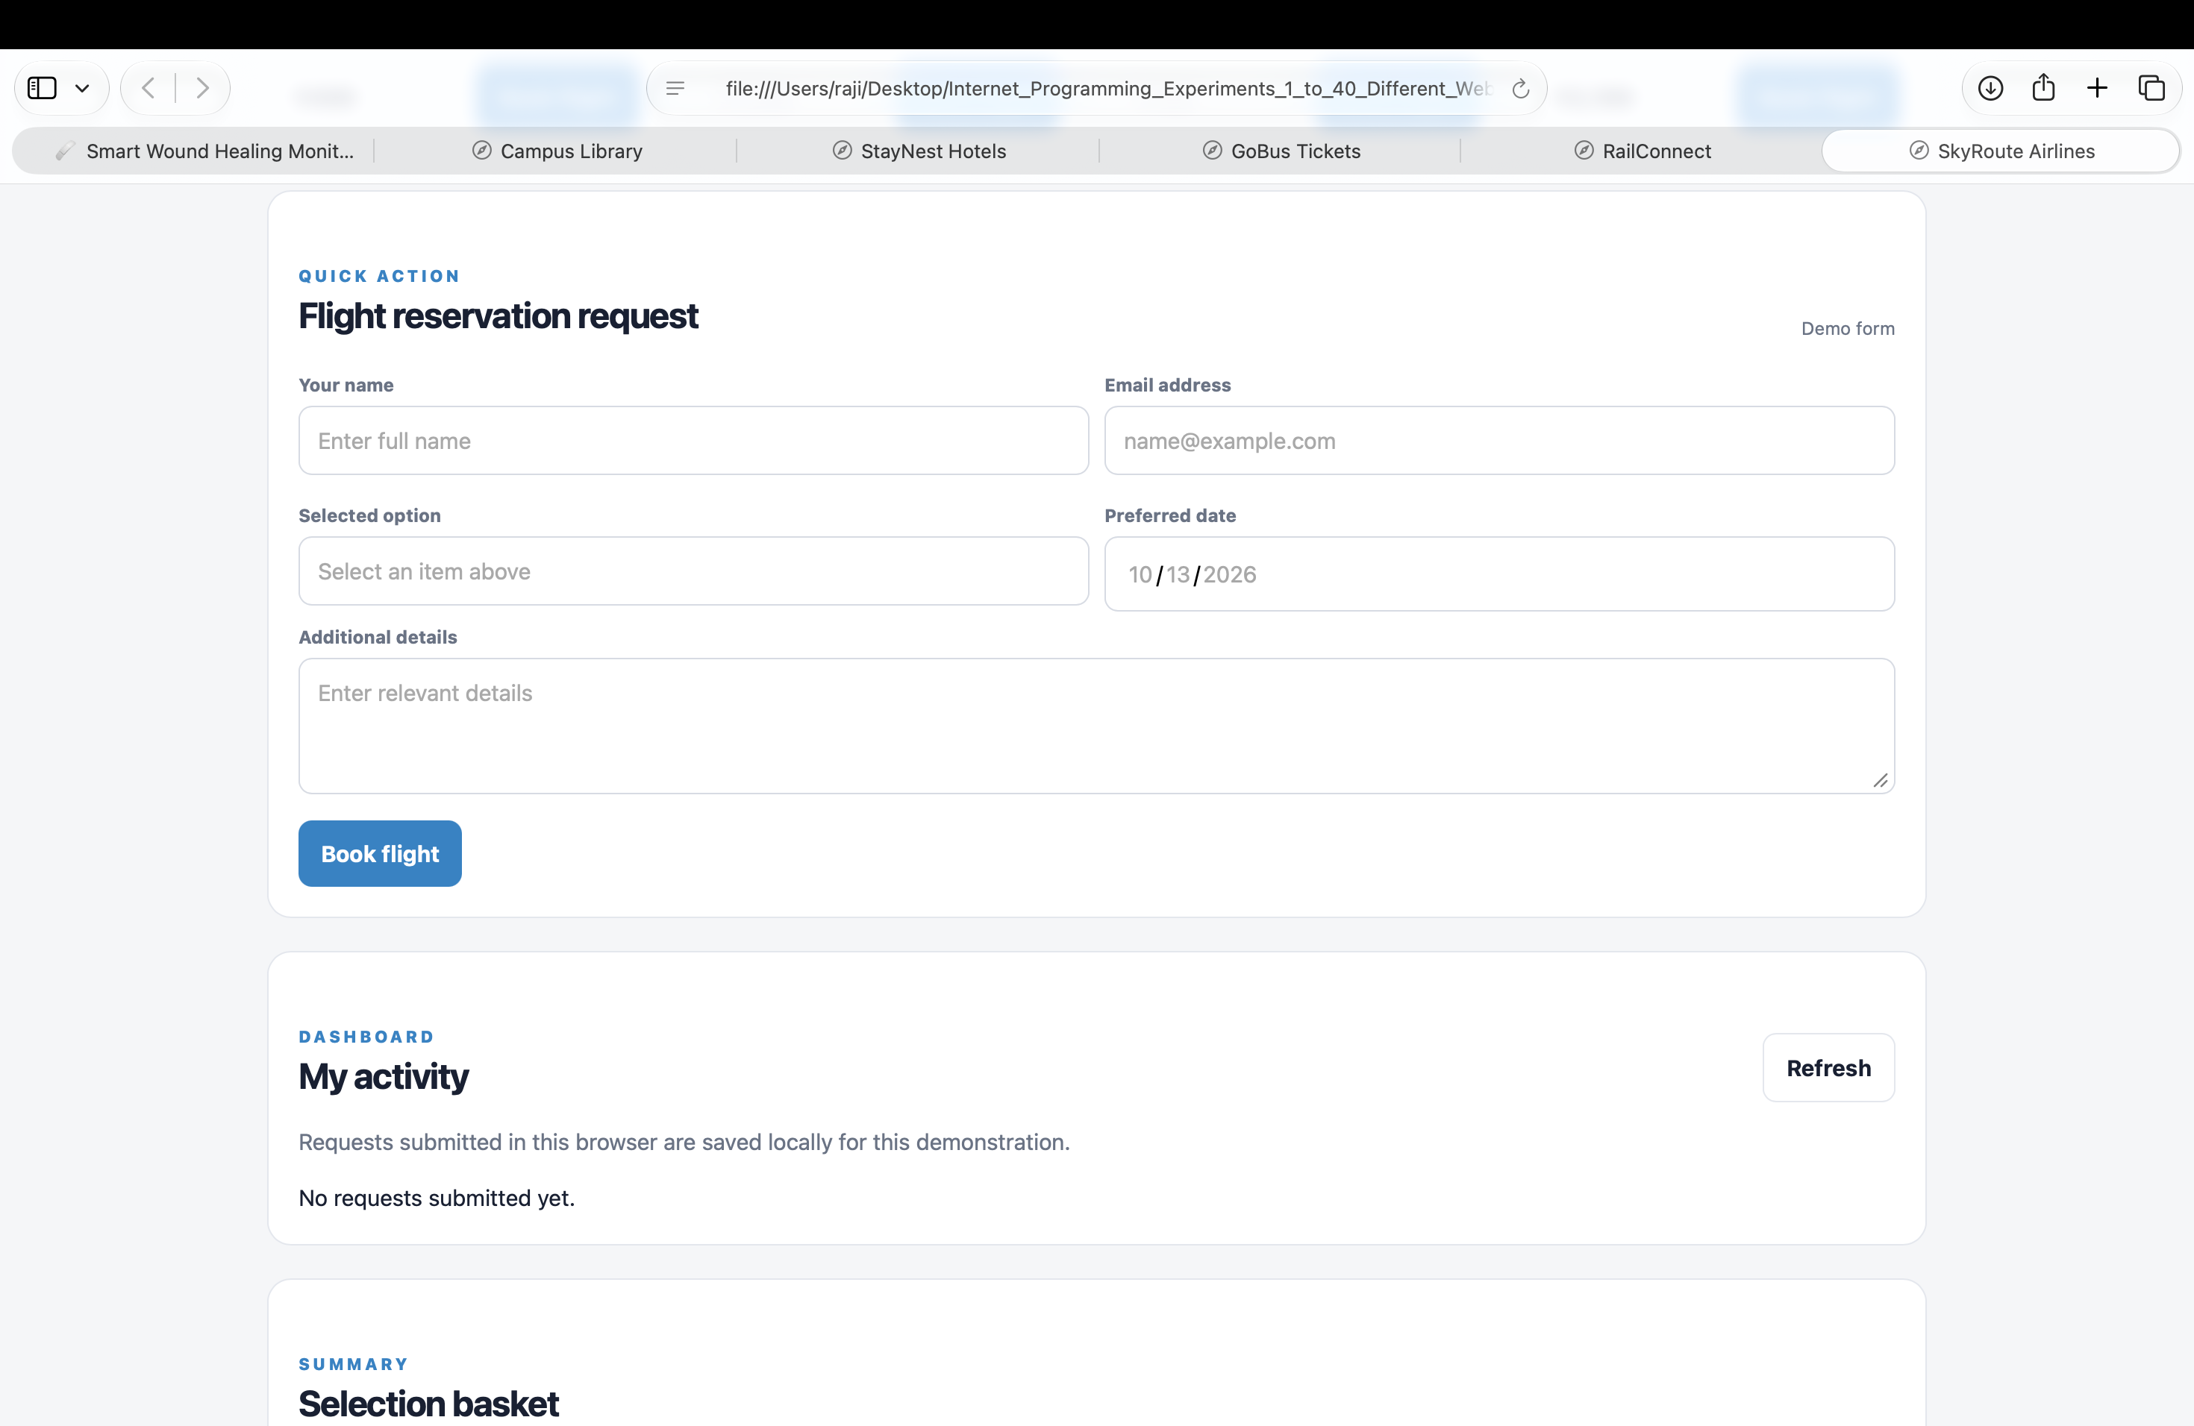
Result: The page runs in a modern browser and displays the sample result when Run Demo is clicked.

Experiment 6: Online Cake Ordering System

Aim
Display cakes and calculate an order total.

Algorithm
- Start and open the page in a web browser.
- Select a cake and quantity, calculate price, and show confirmation.
- Click Run Demo to execute the JavaScript function.
- Display the result on the webpage.
- Stop.

Code (save as index.html)
<!DOCTYPE html>
<html lang="en">
<head>
<meta charset="UTF-8">
<meta name="viewport" content="width=device-width, initial-scale=1.0">
<title>Online Cake Ordering System</title>
<style>
body{font-family:Arial,sans-serif;max-width:760px;margin:40px auto;padding:24px;background:#f3f6fa;color:#172033}
main{background:white;padding:24px;border-radius:12px}h1{color:#155e75}button{padding:9px 16px;cursor:pointer}
</style>
</head>
<body><main><h1>Online Cake Ordering System</h1><p>Display cakes and calculate an order total.</p>
<button onclick="runDemo()">Run Demo</button><p id="result">Click Run Demo to display the sample result.</p></main>
<script>
function runDemo(){document.getElementById('result').textContent="Chocolate Cake \u20b9500 \u00d7 1; Total \u20b9500.";}
</script></body></html>

Expected Output
Chocolate Cake ₹500 × 1; Total ₹500.
Result: The page runs in a modern browser and displays the sample result when Run Demo is clicked.
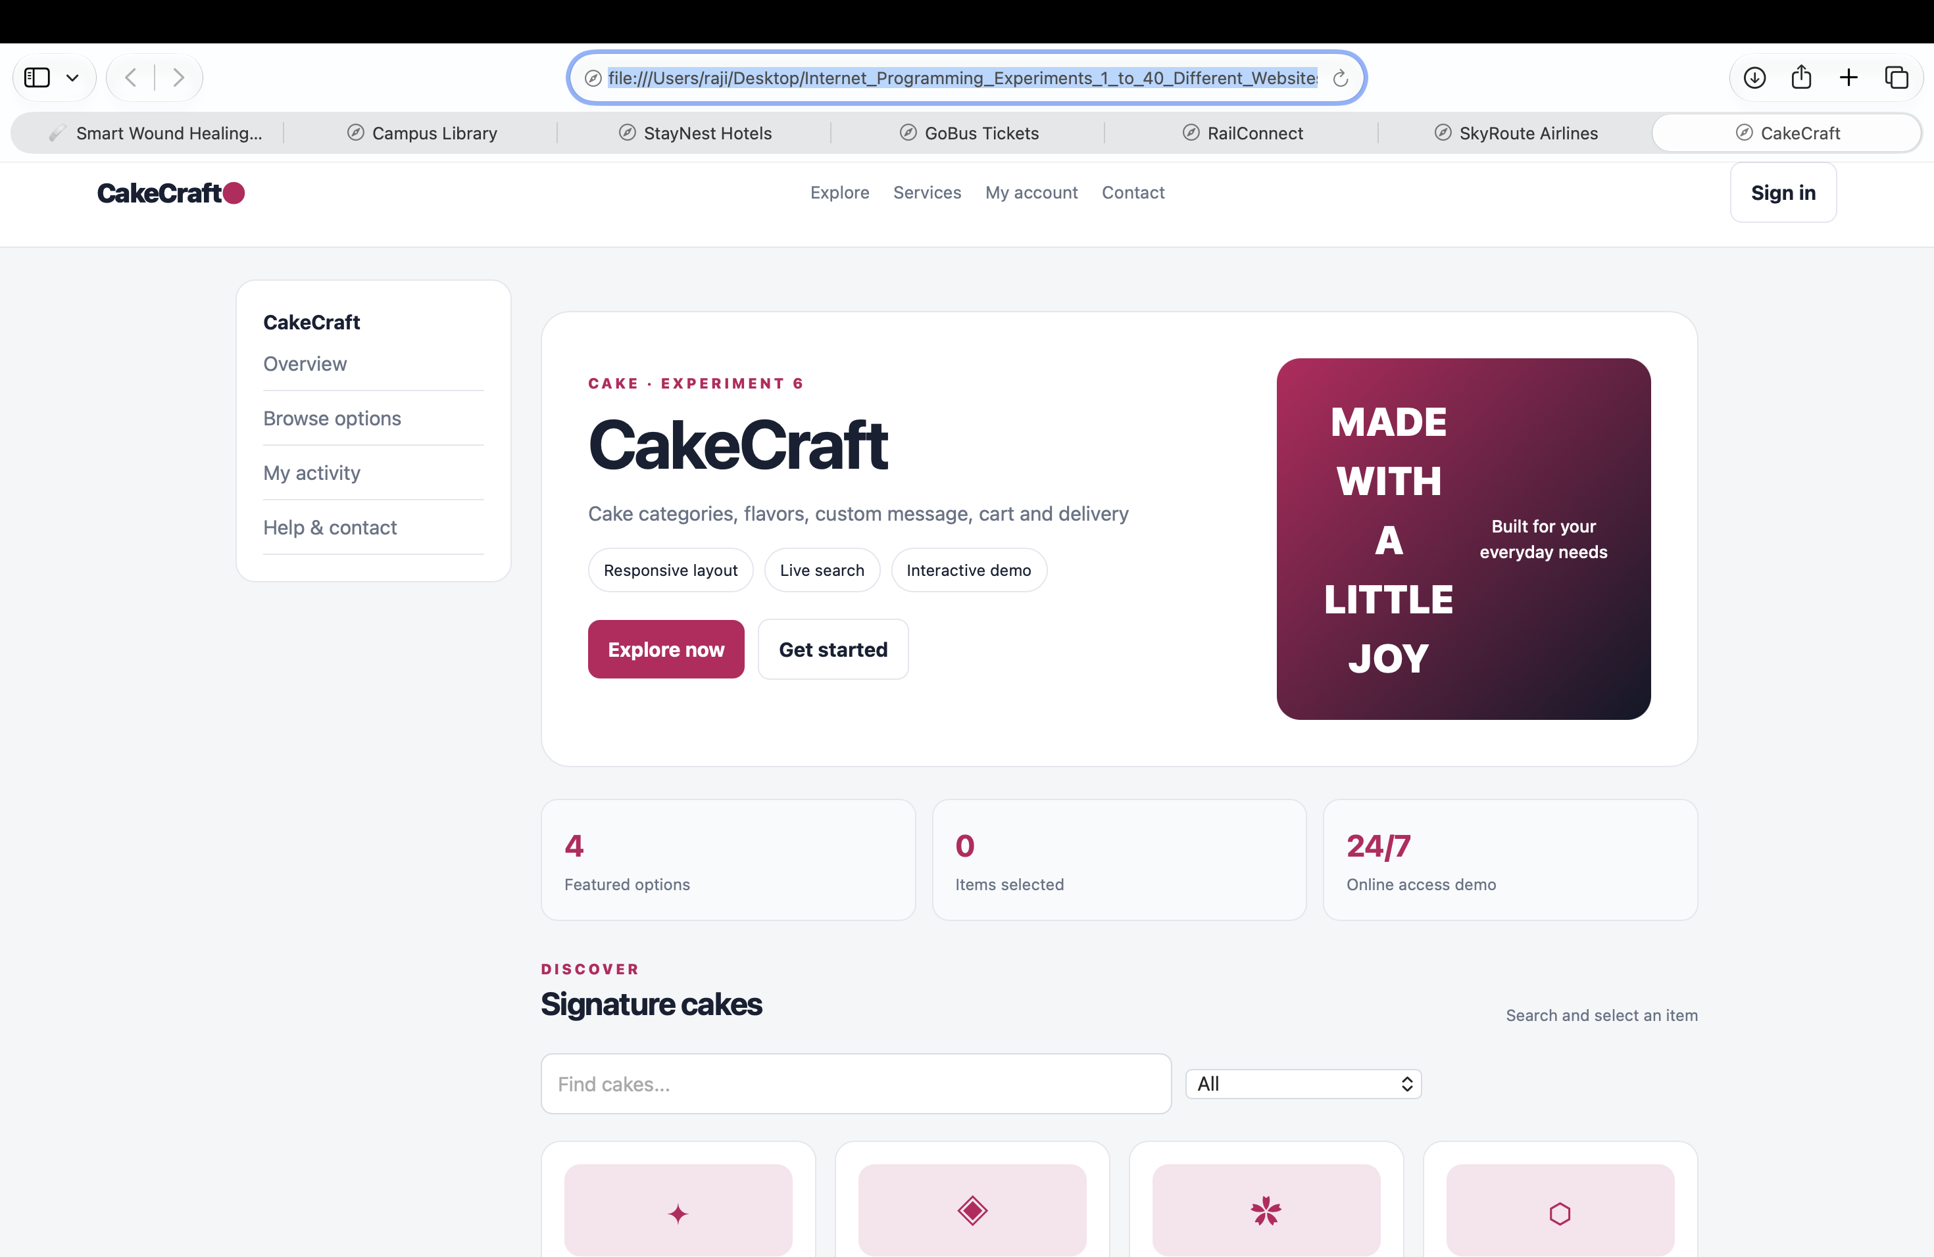

Experiment 7: Beauty Parlour Appointment System

Aim
Book a sample salon appointment.

Algorithm
- Start and open the page in a web browser.
- Choose a service and date, validate customer details, and confirm.
- Click Run Demo to execute the JavaScript function.
- Display the result on the webpage.
- Stop.

Code (save as index.html)
<!DOCTYPE html>
<html lang="en">
<head>
<meta charset="UTF-8">
<meta name="viewport" content="width=device-width, initial-scale=1.0">
<title>Beauty Parlour Appointment System</title>
<style>
body{font-family:Arial,sans-serif;max-width:760px;margin:40px auto;padding:24px;background:#f3f6fa;color:#172033}
main{background:white;padding:24px;border-radius:12px}h1{color:#155e75}button{padding:9px 16px;cursor:pointer}
</style>
</head>
<body><main><h1>Beauty Parlour Appointment System</h1><p>Book a sample salon appointment.</p>
<button onclick="runDemo()">Run Demo</button><p id="result">Click Run Demo to display the sample result.</p></main>
<script>
function runDemo(){document.getElementById('result').textContent="Appointment booked (demo).";}
</script></body></html>

Expected Output
Appointment booked (demo).
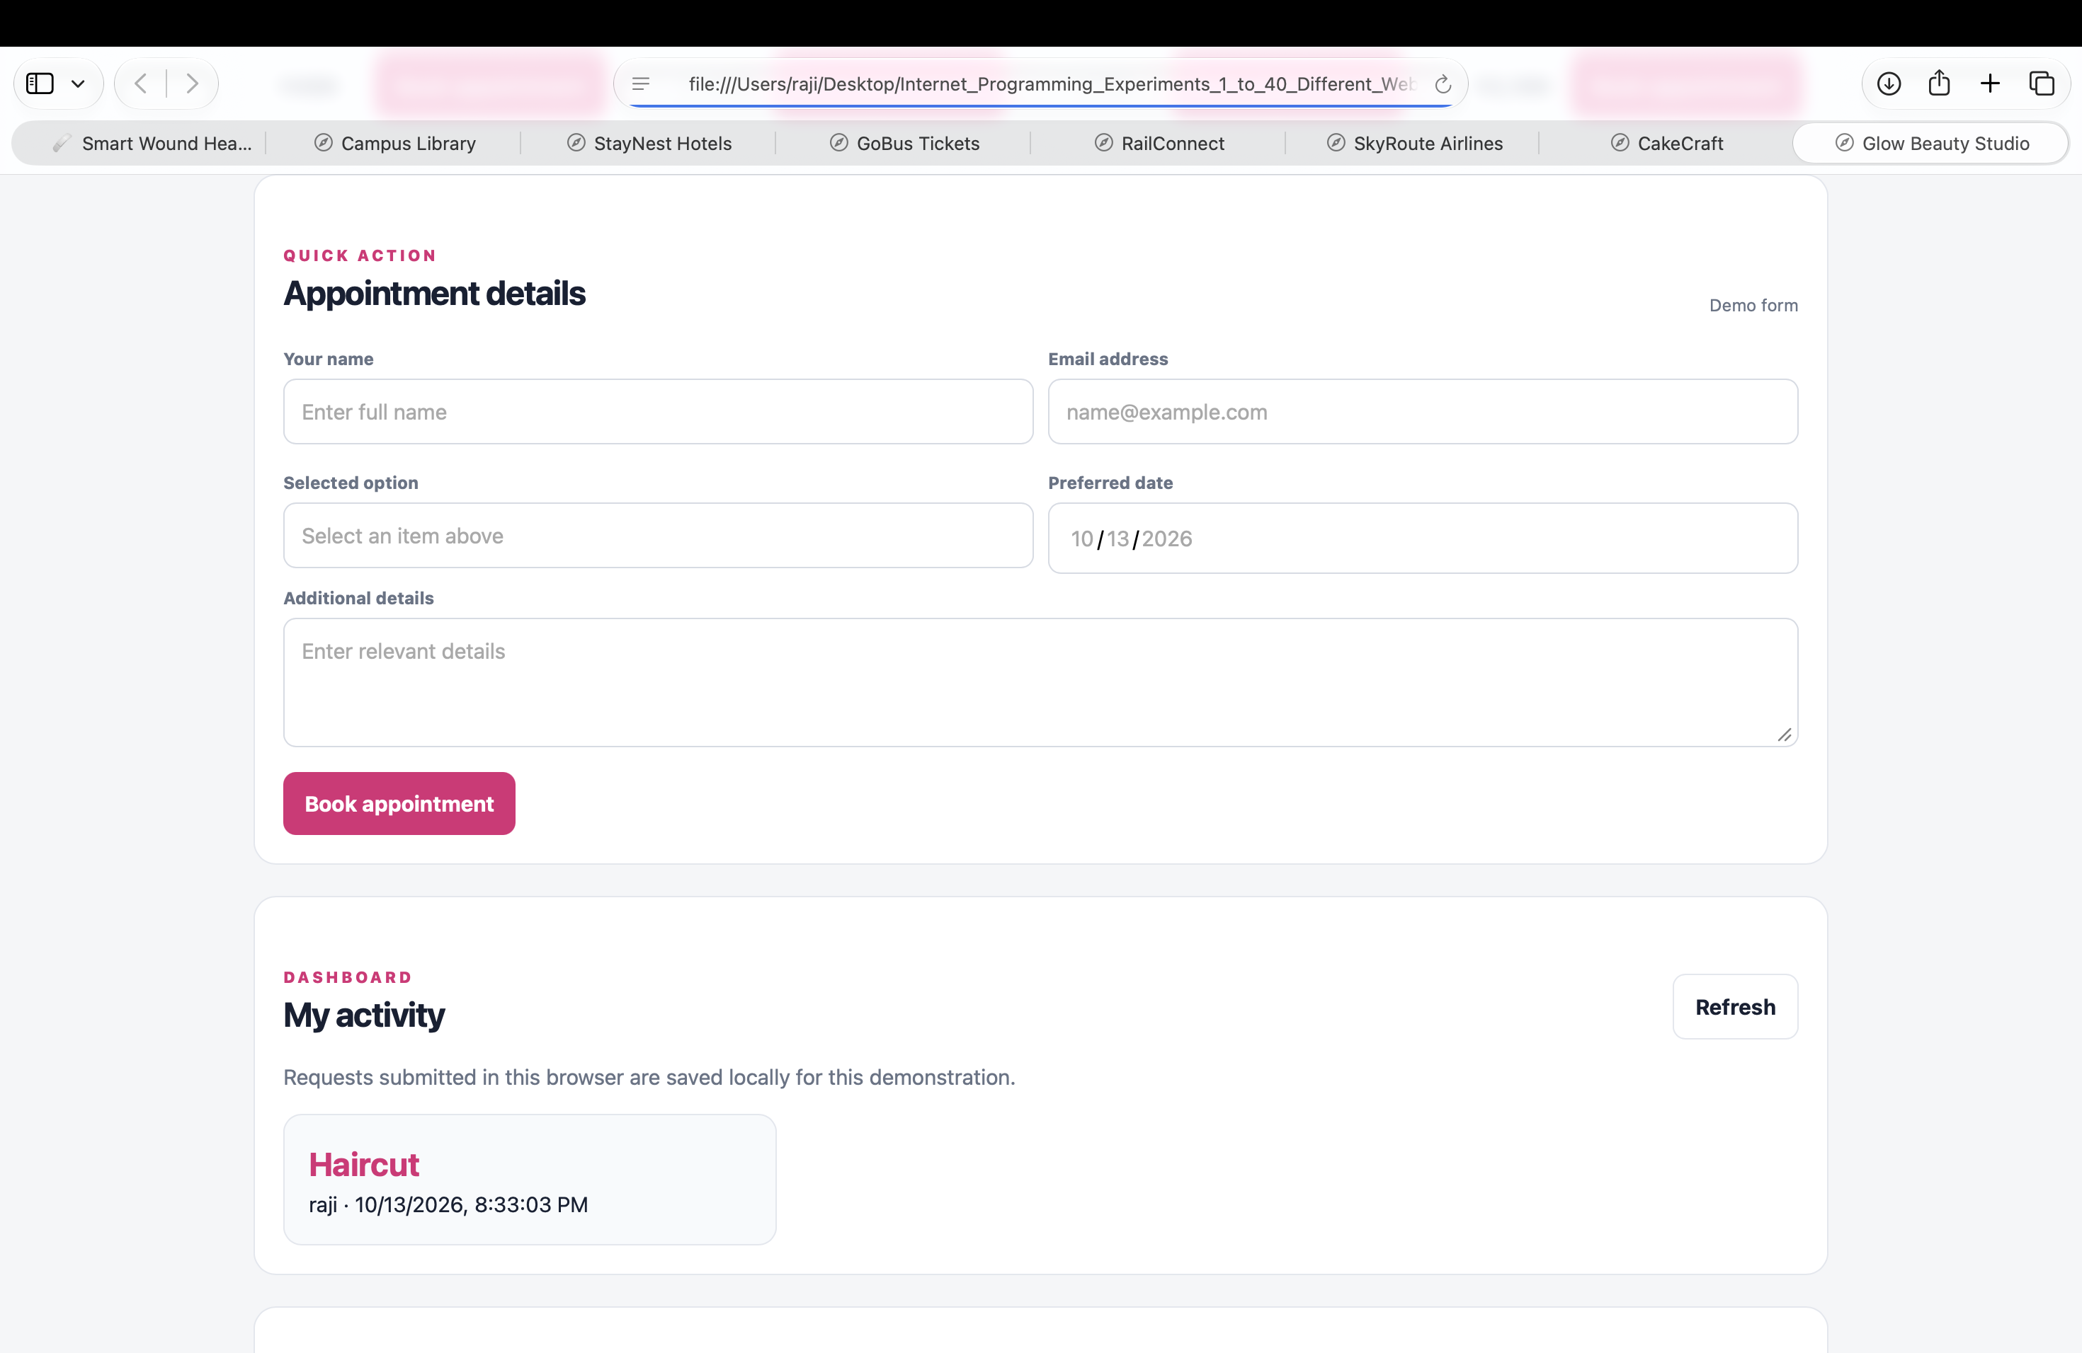
Result: The page runs in a modern browser and displays the sample result when Run Demo is clicked.

Experiment 8: Hospital Appointment System

Aim
Create a doctor appointment page.

Algorithm
- Start and open the page in a web browser.
- Select specialty, doctor and date, then display appointment status.
- Click Run Demo to execute the JavaScript function.
- Display the result on the webpage.
- Stop.

Code (save as index.html)
<!DOCTYPE html>
<html lang="en">
<head>
<meta charset="UTF-8">
<meta name="viewport" content="width=device-width, initial-scale=1.0">
<title>Hospital Appointment System</title>
<style>
body{font-family:Arial,sans-serif;max-width:760px;margin:40px auto;padding:24px;background:#f3f6fa;color:#172033}
main{background:white;padding:24px;border-radius:12px}h1{color:#155e75}button{padding:9px 16px;cursor:pointer}
</style>
</head>
<body><main><h1>Hospital Appointment System</h1><p>Create a doctor appointment page.</p>
<button onclick="runDemo()">Run Demo</button><p id="result">Click Run Demo to display the sample result.</p></main>
<script>
function runDemo(){document.getElementById('result').textContent="Appointment request submitted (demo).";}
</script></body></html>

Expected Output
Appointment request submitted (demo).
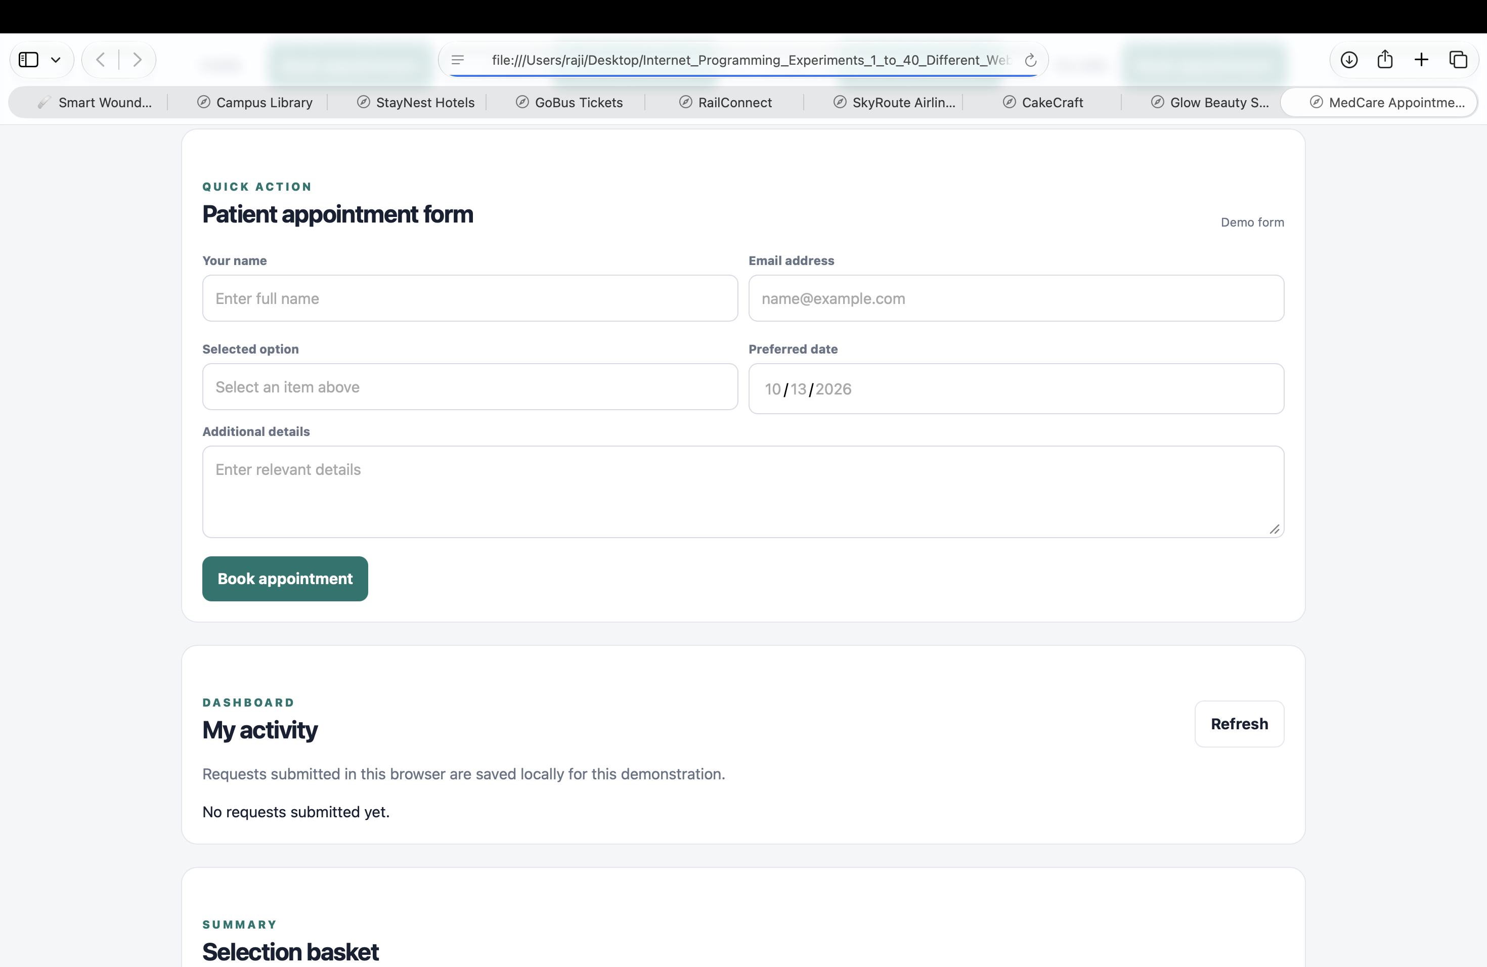
Result: The page runs in a modern browser and displays the sample result when Run Demo is clicked.

Experiment 9: Electronics Shopping System

Aim
Display electronic products and a cart total.

Algorithm
- Start and open the page in a web browser.
- List products, select one, calculate total and show cart summary.
- Click Run Demo to execute the JavaScript function.
- Display the result on the webpage.
- Stop.

Code (save as index.html)
<!DOCTYPE html>
<html lang="en">
<head>
<meta charset="UTF-8">
<meta name="viewport" content="width=device-width, initial-scale=1.0">
<title>Electronics Shopping System</title>
<style>
body{font-family:Arial,sans-serif;max-width:760px;margin:40px auto;padding:24px;background:#f3f6fa;color:#172033}
main{background:white;padding:24px;border-radius:12px}h1{color:#155e75}button{padding:9px 16px;cursor:pointer}
</style>
</head>
<body><main><h1>Electronics Shopping System</h1><p>Display electronic products and a cart total.</p>
<button onclick="runDemo()">Run Demo</button><p id="result">Click Run Demo to display the sample result.</p></main>
<script>
function runDemo(){document.getElementById('result').textContent="Laptop \u20b945000; Cart total \u20b945000.";}
</script></body></html>

Expected Output
Laptop ₹45000; Cart total ₹45000.
Result: The page runs in a modern browser and displays the sample result when Run Demo is clicked.
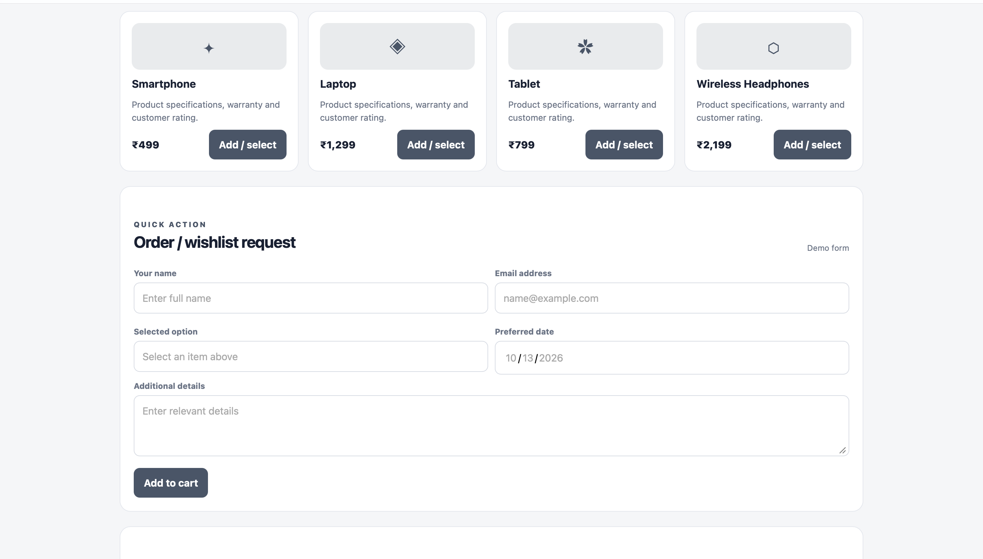

Experiment 10: Fashion Shopping System

Aim
Create a fashion catalogue and cart.

Algorithm
- Start and open the page in a web browser.
- Display products, filter by category, and calculate selected item total.
- Click Run Demo to execute the JavaScript function.
- Display the result on the webpage.
- Stop.

Code (save as index.html)
<!DOCTYPE html>
<html lang="en">
<head>
<meta charset="UTF-8">
<meta name="viewport" content="width=device-width, initial-scale=1.0">
<title>Fashion Shopping System</title>
<style>
body{font-family:Arial,sans-serif;max-width:760px;margin:40px auto;padding:24px;background:#f3f6fa;color:#172033}
main{background:white;padding:24px;border-radius:12px}h1{color:#155e75}button{padding:9px 16px;cursor:pointer}
</style>
</head>
<body><main><h1>Fashion Shopping System</h1><p>Create a fashion catalogue and cart.</p>
<button onclick="runDemo()">Run Demo</button><p id="result">Click Run Demo to display the sample result.</p></main>
<script>
function runDemo(){document.getElementById('result').textContent="T-shirt \u20b9799; selected item total \u20b9799.";}
</script></body></html>

Expected Output
T-shirt ₹799; selected item total ₹799.
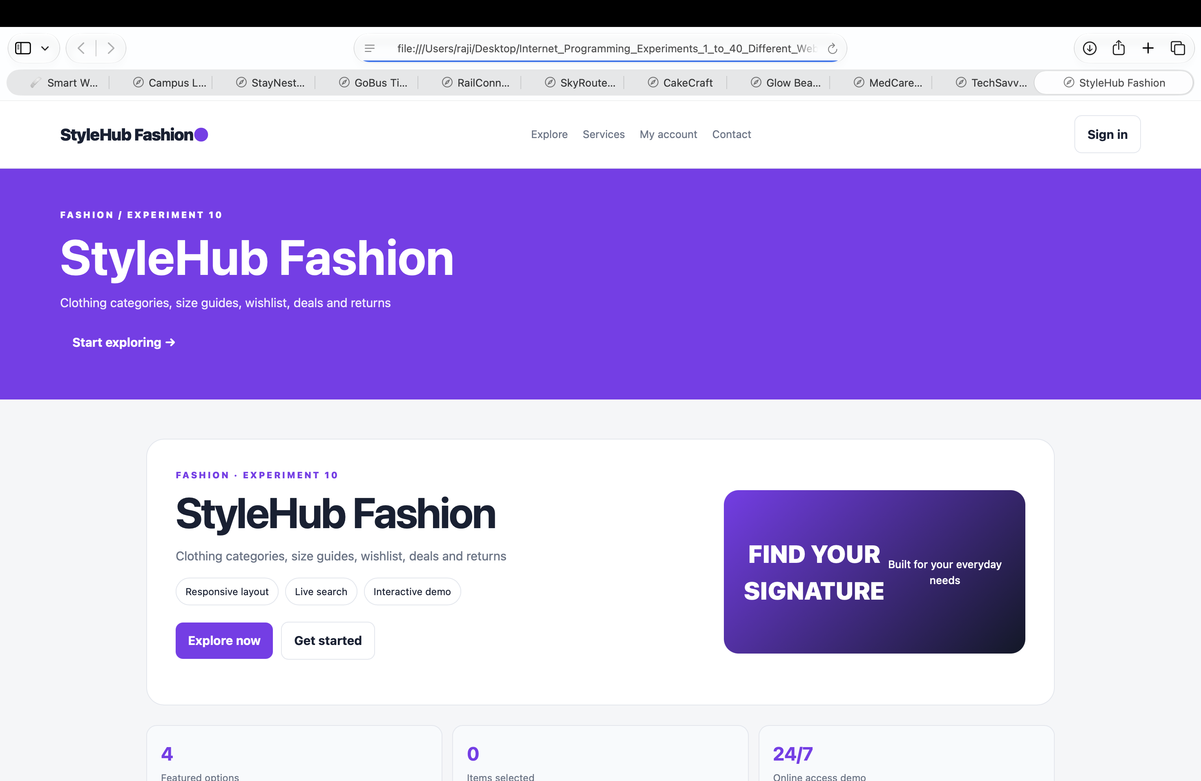
Result: The page runs in a modern browser and displays the sample result when Run Demo is clicked.

Experiment 11: Real Estate Property Finder

Aim
Search properties by location and budget.

Algorithm
- Start and open the page in a web browser.
- Read filters, compare with sample properties, and display matches.
- Click Run Demo to execute the JavaScript function.
- Display the result on the webpage.
- Stop.

Code (save as index.html)
<!DOCTYPE html>
<html lang="en">
<head>
<meta charset="UTF-8">
<meta name="viewport" content="width=device-width, initial-scale=1.0">
<title>Real Estate Property Finder</title>
<style>
body{font-family:Arial,sans-serif;max-width:760px;margin:40px auto;padding:24px;background:#f3f6fa;color:#172033}
main{background:white;padding:24px;border-radius:12px}h1{color:#155e75}button{padding:9px 16px;cursor:pointer}
</style>
</head>
<body><main><h1>Real Estate Property Finder</h1><p>Search properties by location and budget.</p>
<button onclick="runDemo()">Run Demo</button><p id="result">Click Run Demo to display the sample result.</p></main>
<script>
function runDemo(){document.getElementById('result').textContent="2BHK Flat, Chennai \u2013 \u20b945,00,000 (sample).";}
</script></body></html>

Expected Output
2BHK Flat, Chennai – ₹45,00,000 (sample).
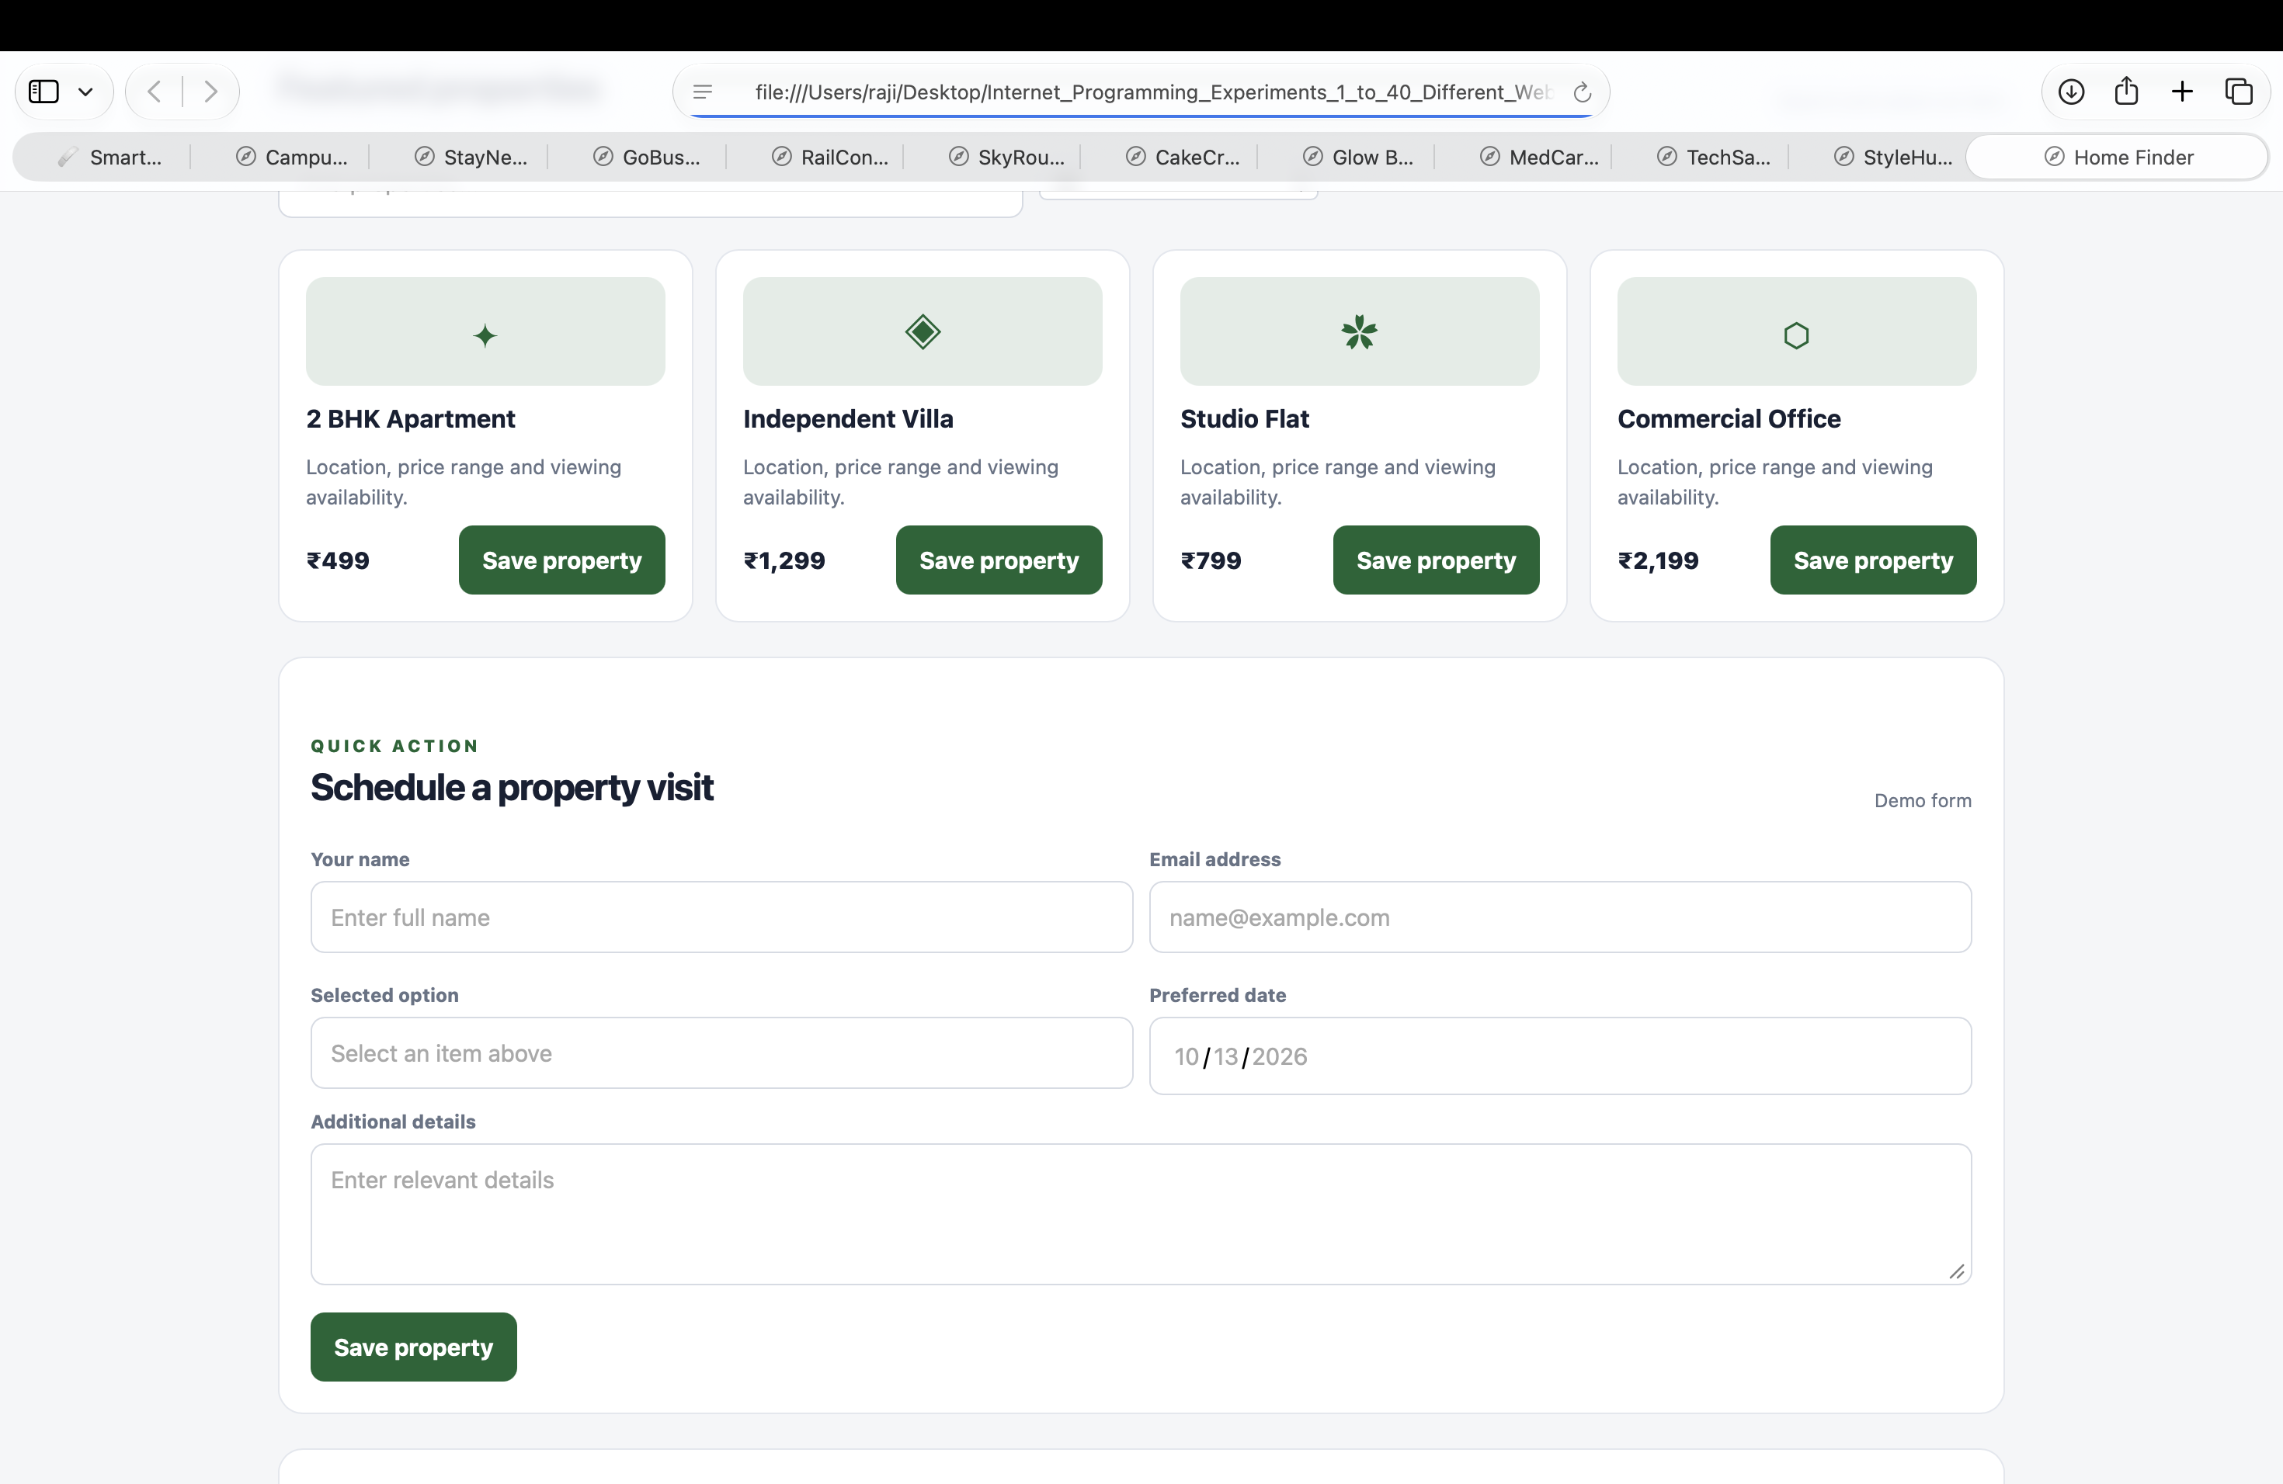
Result: The page runs in a modern browser and displays the sample result when Run Demo is clicked.

Experiment 12: Insurance Management System

Aim
Display insurance policy details.

Algorithm
- Start and open the page in a web browser.
- Select a sample policy and show its premium and coverage.
- Click Run Demo to execute the JavaScript function.
- Display the result on the webpage.
- Stop.

Code (save as index.html)
<!DOCTYPE html>
<html lang="en">
<head>
<meta charset="UTF-8">
<meta name="viewport" content="width=device-width, initial-scale=1.0">
<title>Insurance Management System</title>
<style>
body{font-family:Arial,sans-serif;max-width:760px;margin:40px auto;padding:24px;background:#f3f6fa;color:#172033}
main{background:white;padding:24px;border-radius:12px}h1{color:#155e75}button{padding:9px 16px;cursor:pointer}
</style>
</head>
<body><main><h1>Insurance Management System</h1><p>Display insurance policy details.</p>
<button onclick="runDemo()">Run Demo</button><p id="result">Click Run Demo to display the sample result.</p></main>
<script>
function runDemo(){document.getElementById('result').textContent="Health Plan \u2013 \u20b98,000/year (sample).";}
</script></body></html>

Expected Output
Health Plan – ₹8,000/year (sample).
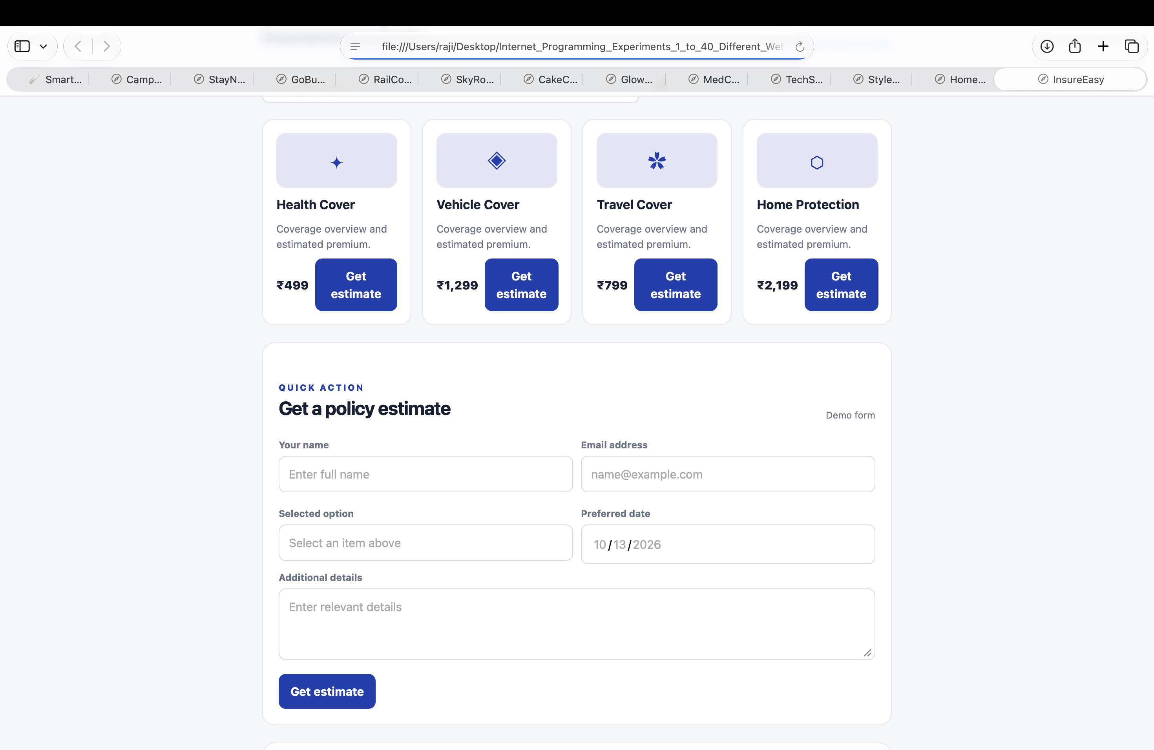
Result: The page runs in a modern browser and displays the sample result when Run Demo is clicked.

Experiment 13: Flowers and Gifts Ordering System

Aim
Display gifts and create an order request.

Algorithm
- Start and open the page in a web browser.
- Select a gift and delivery date, calculate amount, and confirm.
- Click Run Demo to execute the JavaScript function.
- Display the result on the webpage.
- Stop.

Code (save as index.html)
<!DOCTYPE html>
<html lang="en">
<head>
<meta charset="UTF-8">
<meta name="viewport" content="width=device-width, initial-scale=1.0">
<title>Flowers and Gifts Ordering System</title>
<style>
body{font-family:Arial,sans-serif;max-width:760px;margin:40px auto;padding:24px;background:#f3f6fa;color:#172033}
main{background:white;padding:24px;border-radius:12px}h1{color:#155e75}button{padding:9px 16px;cursor:pointer}
</style>
</head>
<body><main><h1>Flowers and Gifts Ordering System</h1><p>Display gifts and create an order request.</p>
<button onclick="runDemo()">Run Demo</button><p id="result">Click Run Demo to display the sample result.</p></main>
<script>
function runDemo(){document.getElementById('result').textContent="Rose Bouquet \u20b9999; order request submitted.";}
</script></body></html>

Expected Output
Rose Bouquet ₹999; order request submitted.
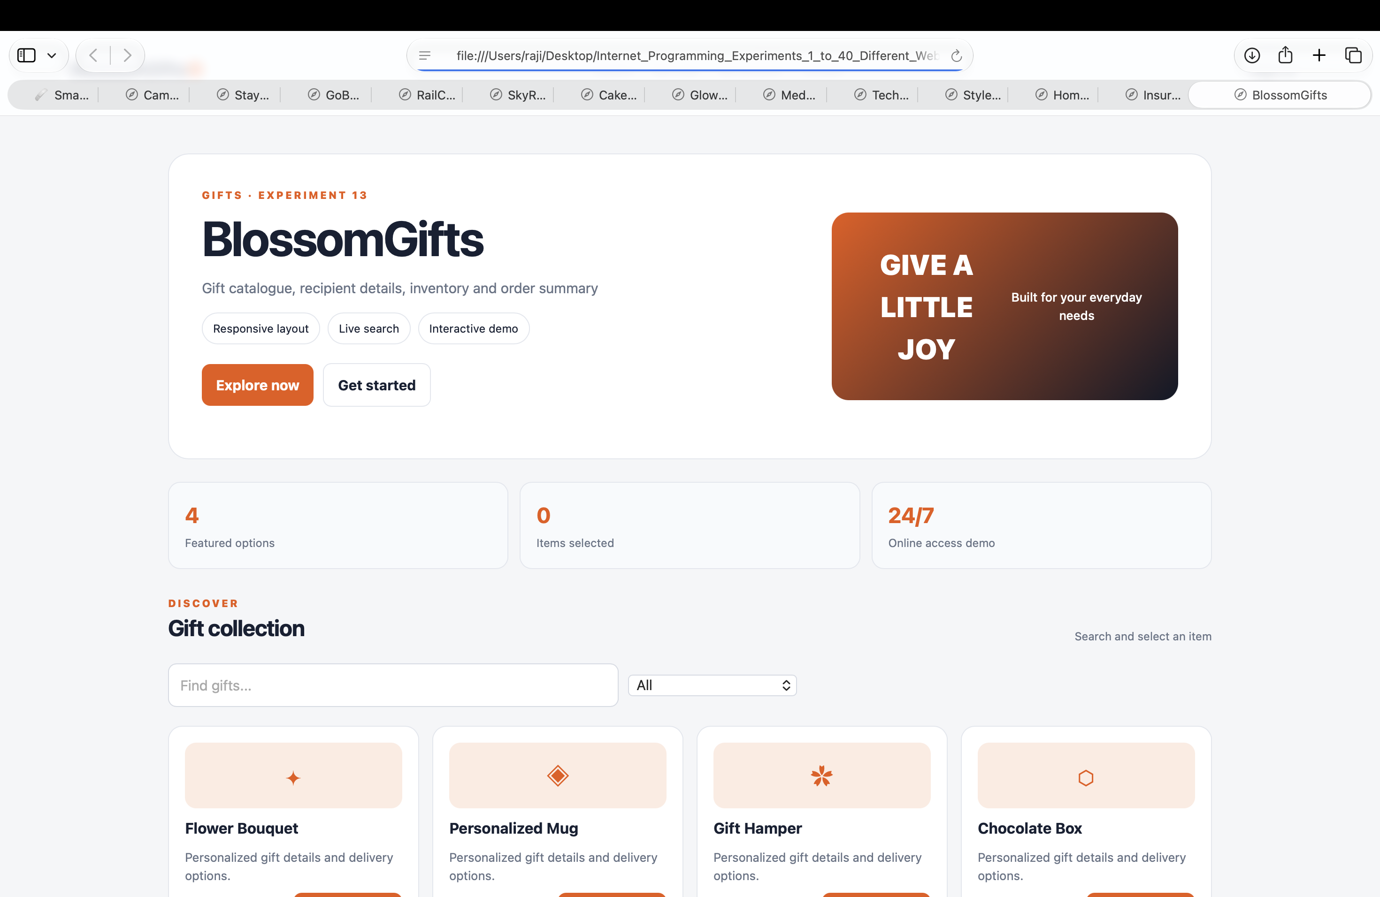
Result: The page runs in a modern browser and displays the sample result when Run Demo is clicked.

Experiment 14: Second-Hand Marketplace

Aim
Display and search used goods listings.

Algorithm
- Start and open the page in a web browser.
- Search sample listings and display matching item and price.
- Click Run Demo to execute the JavaScript function.
- Display the result on the webpage.
- Stop.

Code (save as index.html)
<!DOCTYPE html>
<html lang="en">
<head>
<meta charset="UTF-8">
<meta name="viewport" content="width=device-width, initial-scale=1.0">
<title>Second-Hand Marketplace</title>
<style>
body{font-family:Arial,sans-serif;max-width:760px;margin:40px auto;padding:24px;background:#f3f6fa;color:#172033}
main{background:white;padding:24px;border-radius:12px}h1{color:#155e75}button{padding:9px 16px;cursor:pointer}
</style>
</head>
<body><main><h1>Second-Hand Marketplace</h1><p>Display and search used goods listings.</p>
<button onclick="runDemo()">Run Demo</button><p id="result">Click Run Demo to display the sample result.</p></main>
<script>
function runDemo(){document.getElementById('result').textContent="Used bicycle \u2013 \u20b93,500 (sample).";}
</script></body></html>

Expected Output
Used bicycle – ₹3,500 (sample).
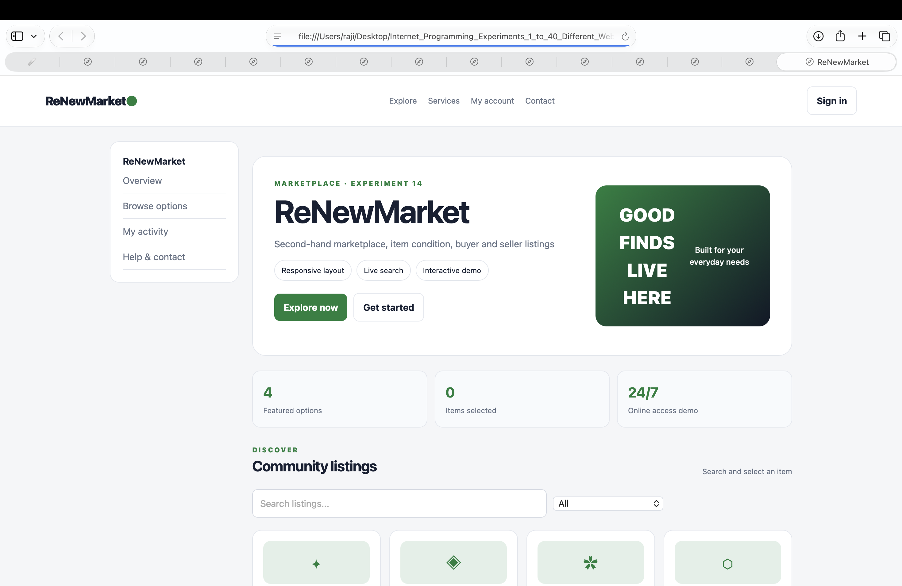
Result: The page runs in a modern browser and displays the sample result when Run Demo is clicked.

Experiment 15: Online Toll Payment System

Aim
Demonstrate a toll payment screen.

Algorithm
- Start and open the page in a web browser.
- Enter toll amount, validate it, and display demo payment status.
- Click Run Demo to execute the JavaScript function.
- Display the result on the webpage.
- Stop.

Code (save as index.html)
<!DOCTYPE html>
<html lang="en">
<head>
<meta charset="UTF-8">
<meta name="viewport" content="width=device-width, initial-scale=1.0">
<title>Online Toll Payment System</title>
<style>
body{font-family:Arial,sans-serif;max-width:760px;margin:40px auto;padding:24px;background:#f3f6fa;color:#172033}
main{background:white;padding:24px;border-radius:12px}h1{color:#155e75}button{padding:9px 16px;cursor:pointer}
</style>
</head>
<body><main><h1>Online Toll Payment System</h1><p>Demonstrate a toll payment screen.</p>
<button onclick="runDemo()">Run Demo</button><p id="result">Click Run Demo to display the sample result.</p></main>
<script>
function runDemo(){document.getElementById('result').textContent="Payment status: Successful (demo).";}
</script></body></html>

Expected Output
Payment status: Successful (demo).
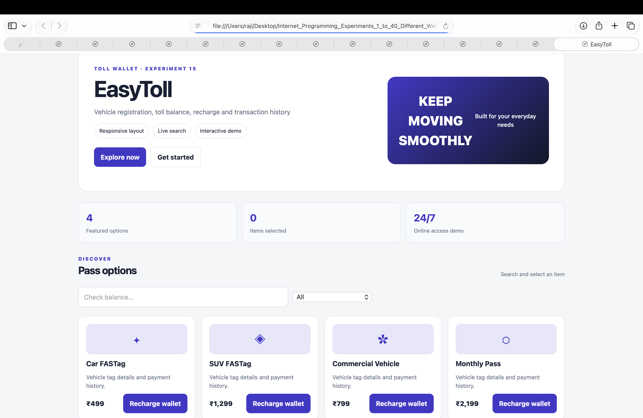
Result: The page runs in a modern browser and displays the sample result when Run Demo is clicked.

Experiment 16: Online Complaint Management System

Aim
Submit a complaint and display its status.

Algorithm
- Start and open the page in a web browser.
- Enter category and description, then generate a sample complaint ID.
- Click Run Demo to execute the JavaScript function.
- Display the result on the webpage.
- Stop.

Code (save as index.html)
<!DOCTYPE html>
<html lang="en">
<head>
<meta charset="UTF-8">
<meta name="viewport" content="width=device-width, initial-scale=1.0">
<title>Online Complaint Management System</title>
<style>
body{font-family:Arial,sans-serif;max-width:760px;margin:40px auto;padding:24px;background:#f3f6fa;color:#172033}
main{background:white;padding:24px;border-radius:12px}h1{color:#155e75}button{padding:9px 16px;cursor:pointer}
</style>
</head>
<body><main><h1>Online Complaint Management System</h1><p>Submit a complaint and display its status.</p>
<button onclick="runDemo()">Run Demo</button><p id="result">Click Run Demo to display the sample result.</p></main>
<script>
function runDemo(){document.getElementById('result').textContent="Complaint ID CMP1001; Status Submitted.";}
</script></body></html>

Expected Output
Complaint ID CMP1001; Status Submitted.
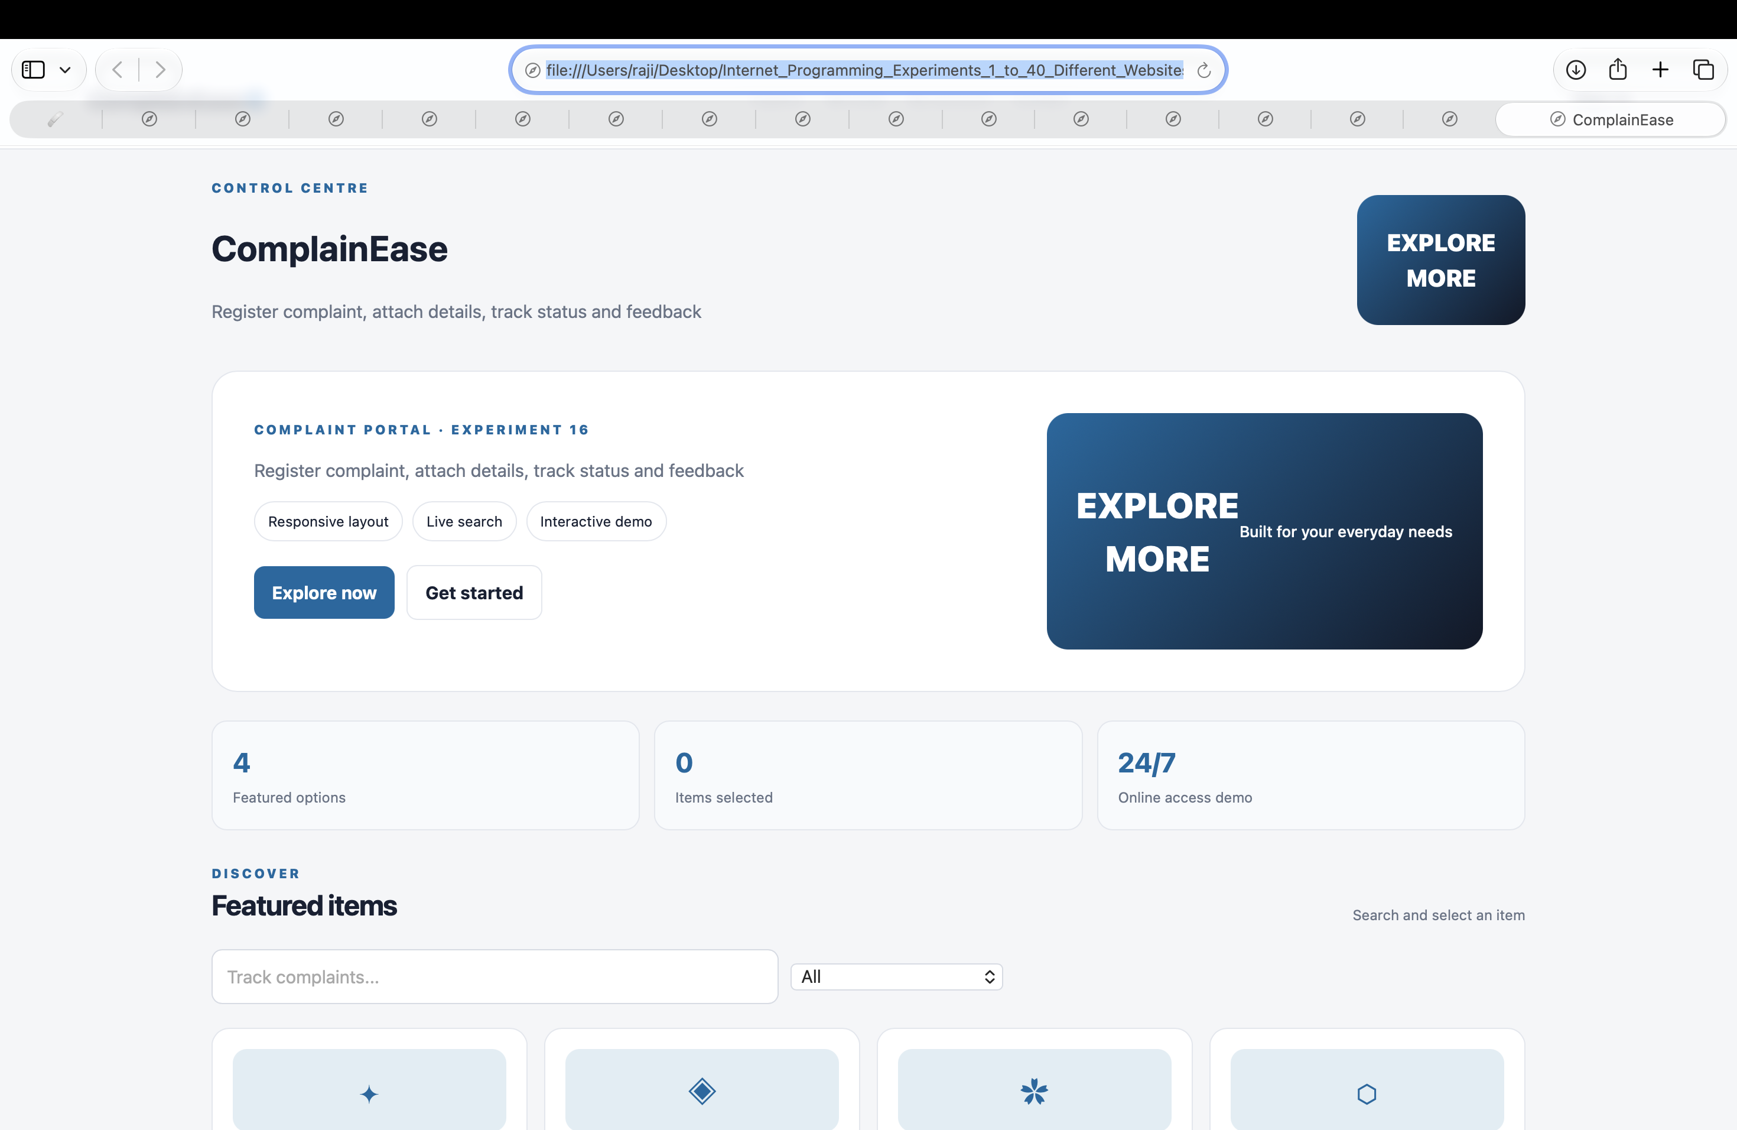
Result: The page runs in a modern browser and displays the sample result when Run Demo is clicked.

Experiment 17: Online Voting System

Aim
Demonstrate candidate selection.

Algorithm
- Start and open the page in a web browser.
- Display candidates, select one, and show a demo confirmation.
- Click Run Demo to execute the JavaScript function.
- Display the result on the webpage.
- Stop.

Code (save as index.html)
<!DOCTYPE html>
<html lang="en">
<head>
<meta charset="UTF-8">
<meta name="viewport" content="width=device-width, initial-scale=1.0">
<title>Online Voting System</title>
<style>
body{font-family:Arial,sans-serif;max-width:760px;margin:40px auto;padding:24px;background:#f3f6fa;color:#172033}
main{background:white;padding:24px;border-radius:12px}h1{color:#155e75}button{padding:9px 16px;cursor:pointer}
</style>
</head>
<body><main><h1>Online Voting System</h1><p>Demonstrate candidate selection.</p>
<button onclick="runDemo()">Run Demo</button><p id="result">Click Run Demo to display the sample result.</p></main>
<script>
function runDemo(){document.getElementById('result').textContent="Vote submitted (demo only).";}
</script></body></html>

Expected Output
Vote submitted (demo only).
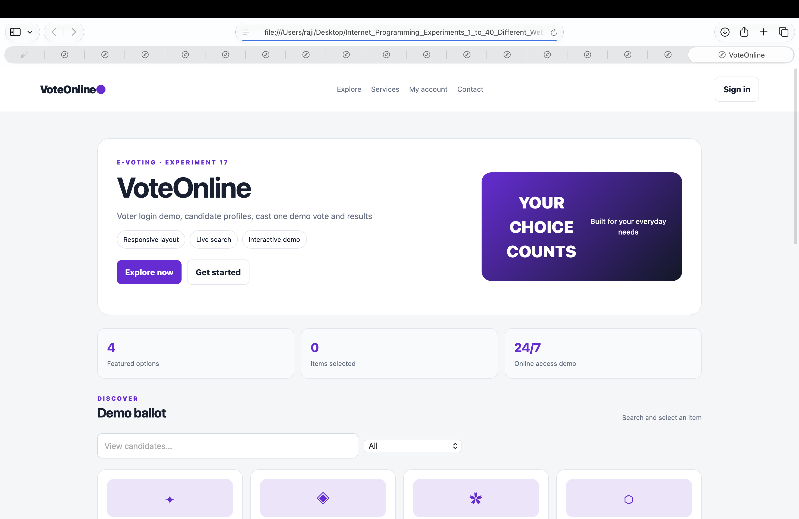
Result: The page runs in a modern browser and displays the sample result when Run Demo is clicked.

Experiment 18: Agricultural Products Marketplace

Aim
Display agricultural products and order totals.

Algorithm
- Start and open the page in a web browser.
- Select product and quantity, calculate total, and display summary.
- Click Run Demo to execute the JavaScript function.
- Display the result on the webpage.
- Stop.

Code (save as index.html)
<!DOCTYPE html>
<html lang="en">
<head>
<meta charset="UTF-8">
<meta name="viewport" content="width=device-width, initial-scale=1.0">
<title>Agricultural Products Marketplace</title>
<style>
body{font-family:Arial,sans-serif;max-width:760px;margin:40px auto;padding:24px;background:#f3f6fa;color:#172033}
main{background:white;padding:24px;border-radius:12px}h1{color:#155e75}button{padding:9px 16px;cursor:pointer}
</style>
</head>
<body><main><h1>Agricultural Products Marketplace</h1><p>Display agricultural products and order totals.</p>
<button onclick="runDemo()">Run Demo</button><p id="result">Click Run Demo to display the sample result.</p></main>
<script>
function runDemo(){document.getElementById('result').textContent="Seeds \u20b9250 \u00d7 2; Total \u20b9500.";}
</script></body></html>

Expected Output
Seeds ₹250 × 2; Total ₹500.
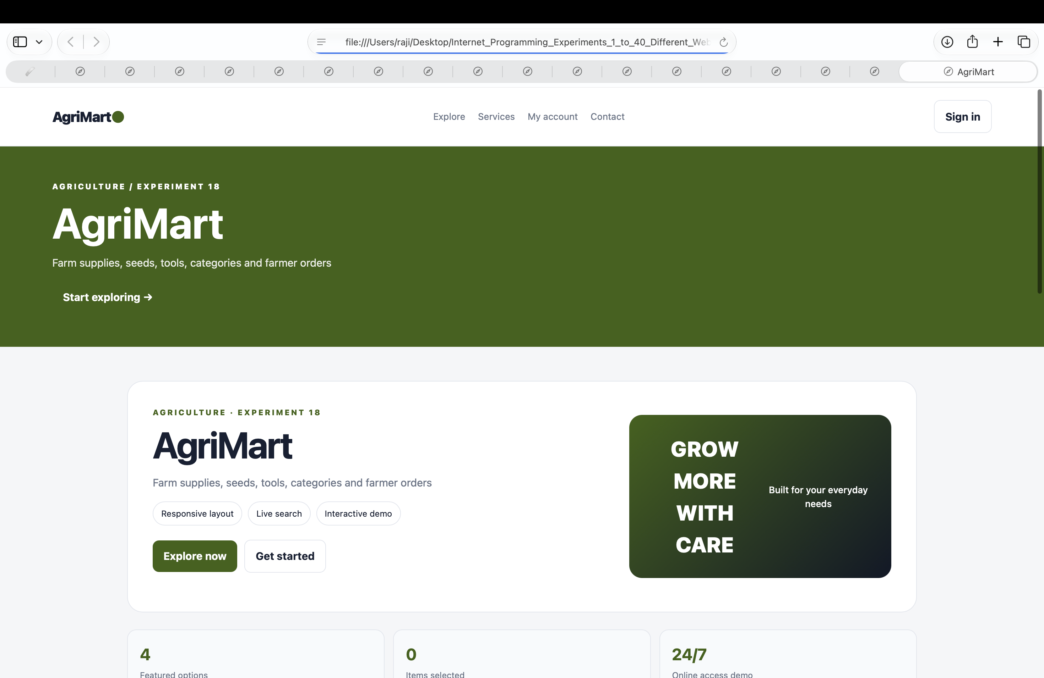
Result: The page runs in a modern browser and displays the sample result when Run Demo is clicked.

Experiment 19: Veterinary Consultation System

Aim
Submit an animal health consultation request.

Algorithm
- Start and open the page in a web browser.
- Enter animal type and symptoms, validate, and show request status.
- Click Run Demo to execute the JavaScript function.
- Display the result on the webpage.
- Stop.

Code (save as index.html)
<!DOCTYPE html>
<html lang="en">
<head>
<meta charset="UTF-8">
<meta name="viewport" content="width=device-width, initial-scale=1.0">
<title>Veterinary Consultation System</title>
<style>
body{font-family:Arial,sans-serif;max-width:760px;margin:40px auto;padding:24px;background:#f3f6fa;color:#172033}
main{background:white;padding:24px;border-radius:12px}h1{color:#155e75}button{padding:9px 16px;cursor:pointer}
</style>
</head>
<body><main><h1>Veterinary Consultation System</h1><p>Submit an animal health consultation request.</p>
<button onclick="runDemo()">Run Demo</button><p id="result">Click Run Demo to display the sample result.</p></main>
<script>
function runDemo(){document.getElementById('result').textContent="Request status: Sent (demo).";}
</script></body></html>

Expected Output
Request status: Sent (demo).
Result: The page runs in a modern browser and displays the sample result when Run Demo is clicked.
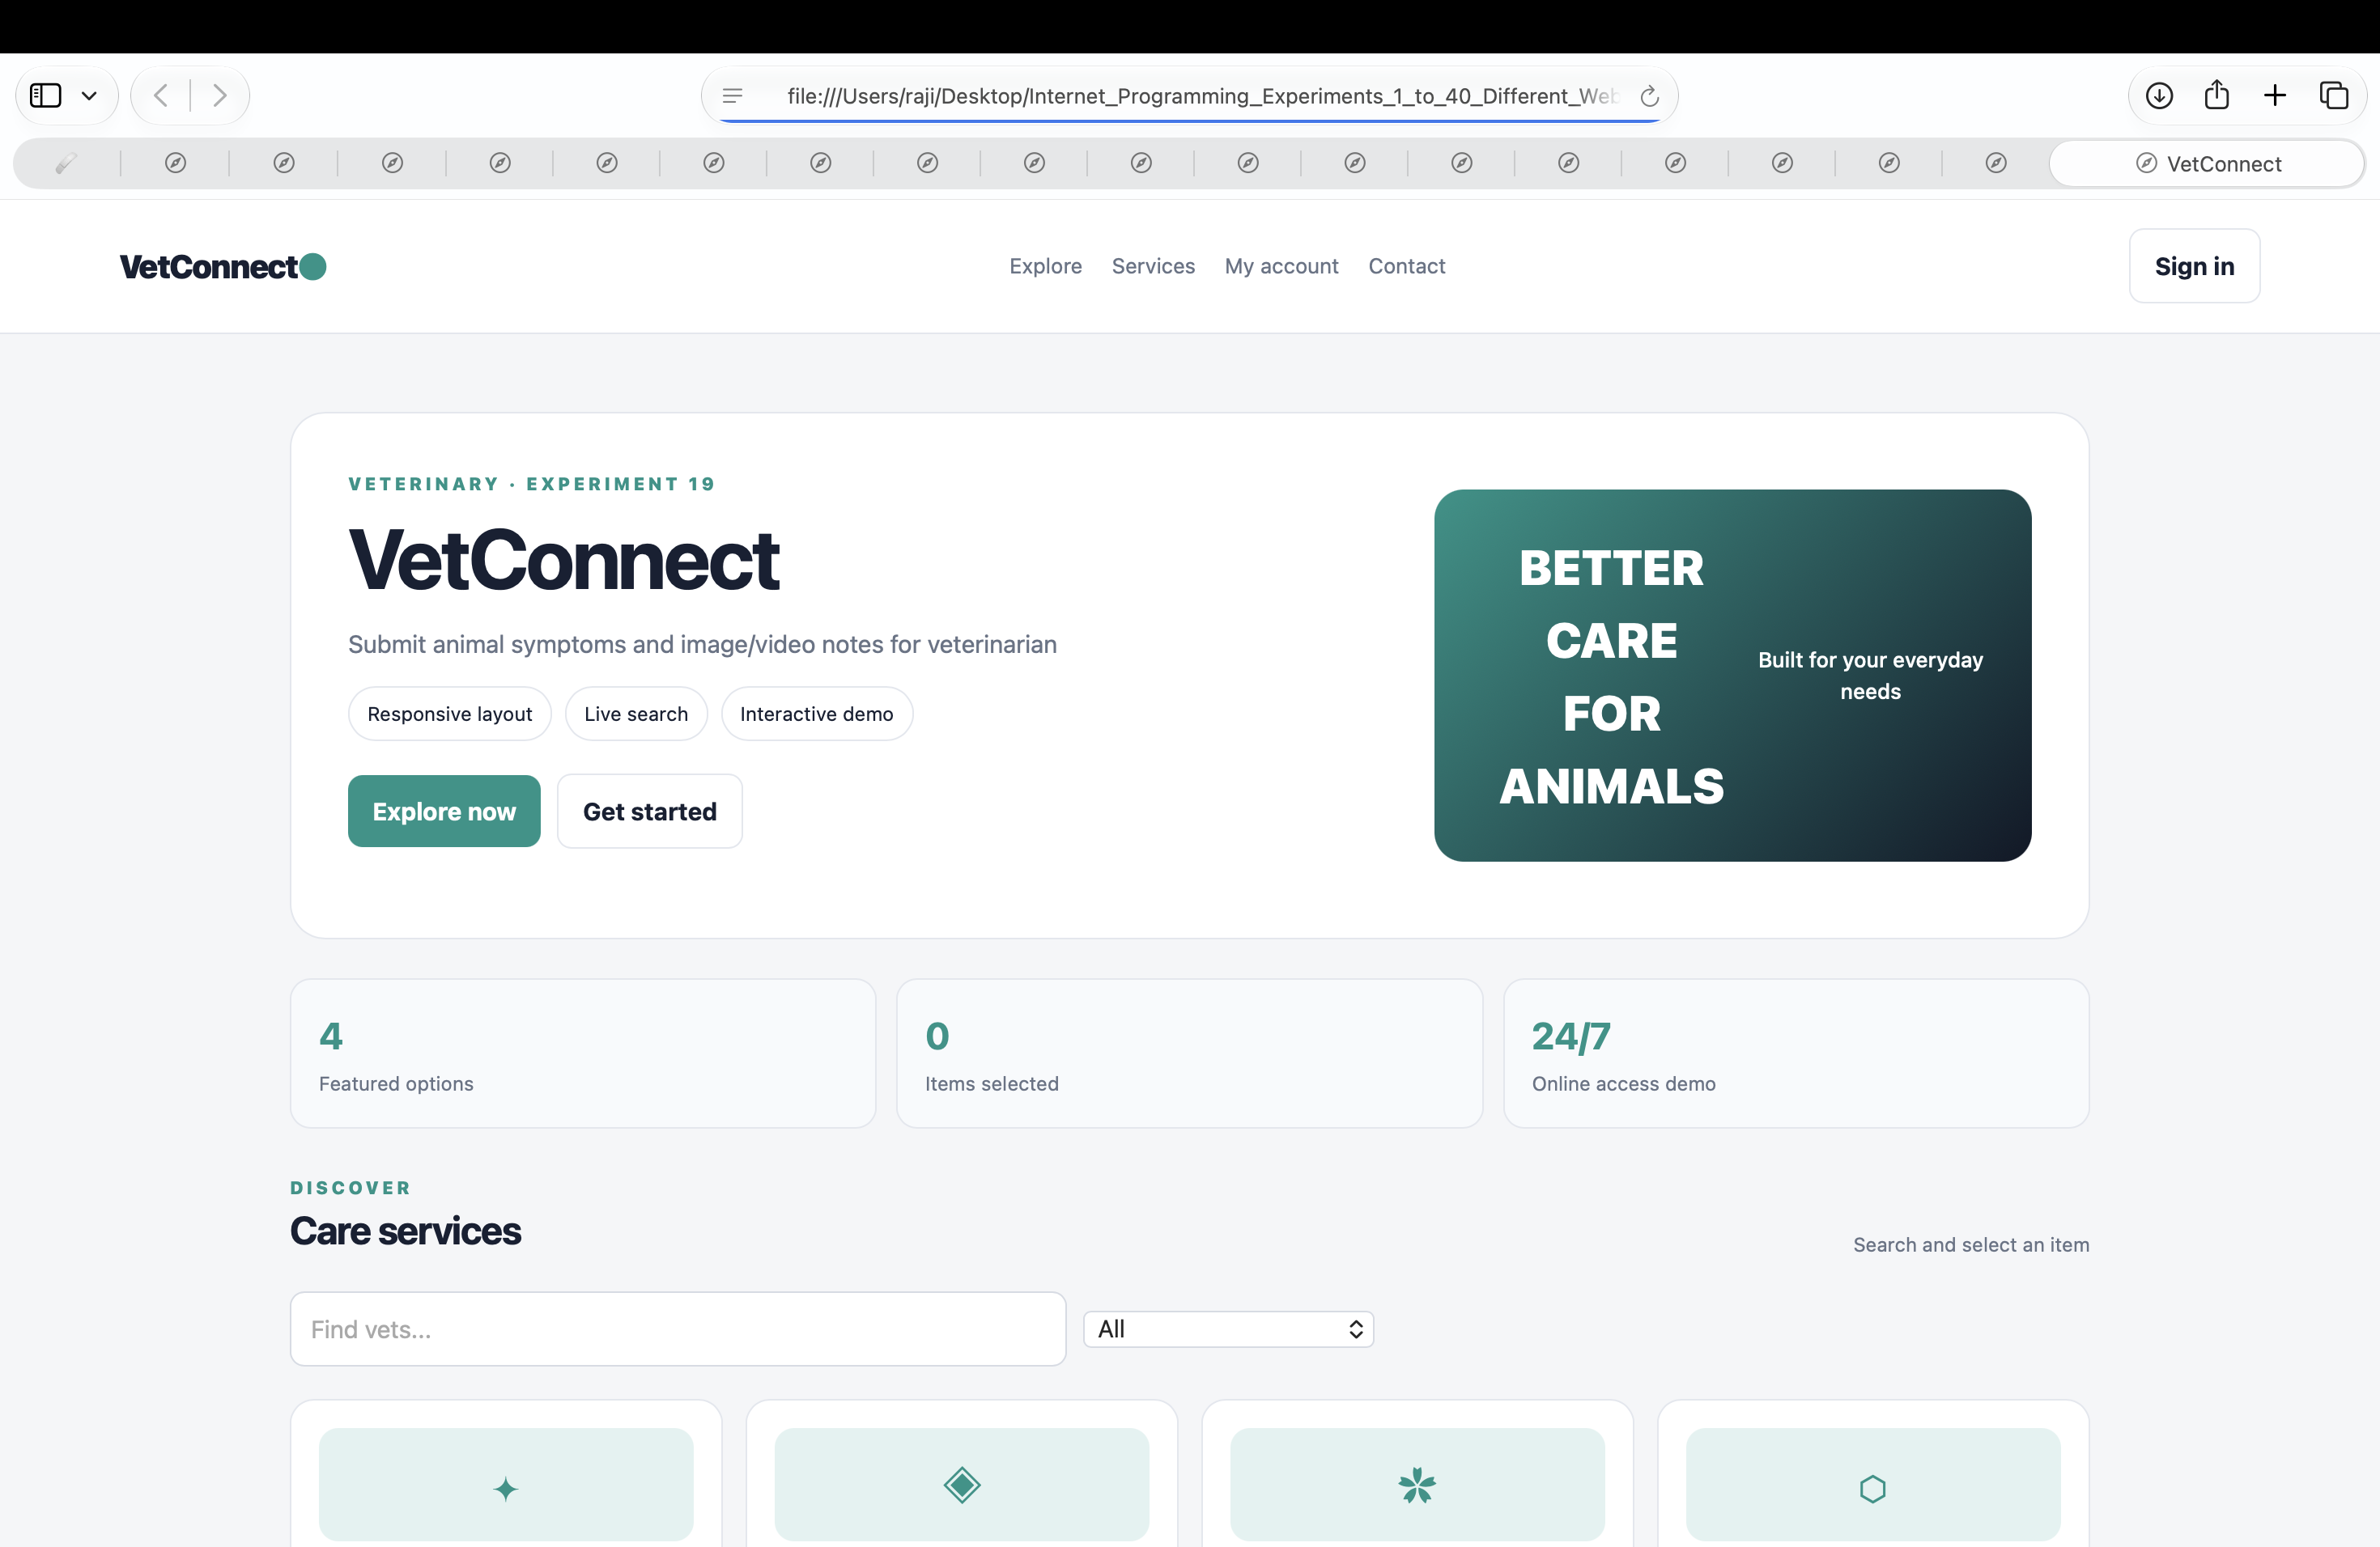

Experiment 20: Vehicle Rental System

Aim
Calculate vehicle rental cost.

Algorithm
- Start and open the page in a web browser.
- Choose vehicle and rental days, multiply daily rate by days, and show total.
- Click Run Demo to execute the JavaScript function.
- Display the result on the webpage.
- Stop.

Code (save as index.html)
<!DOCTYPE html>
<html lang="en">
<head>
<meta charset="UTF-8">
<meta name="viewport" content="width=device-width, initial-scale=1.0">
<title>Vehicle Rental System</title>
<style>
body{font-family:Arial,sans-serif;max-width:760px;margin:40px auto;padding:24px;background:#f3f6fa;color:#172033}
main{background:white;padding:24px;border-radius:12px}h1{color:#155e75}button{padding:9px 16px;cursor:pointer}
</style>
</head>
<body><main><h1>Vehicle Rental System</h1><p>Calculate vehicle rental cost.</p>
<button onclick="runDemo()">Run Demo</button><p id="result">Click Run Demo to display the sample result.</p></main>
<script>
function runDemo(){document.getElementById('result').textContent="\u20b92,000/day \u00d7 2 days; Total \u20b94,000.";}
</script></body></html>

Expected Output
₹2,000/day × 2 days; Total ₹4,000.
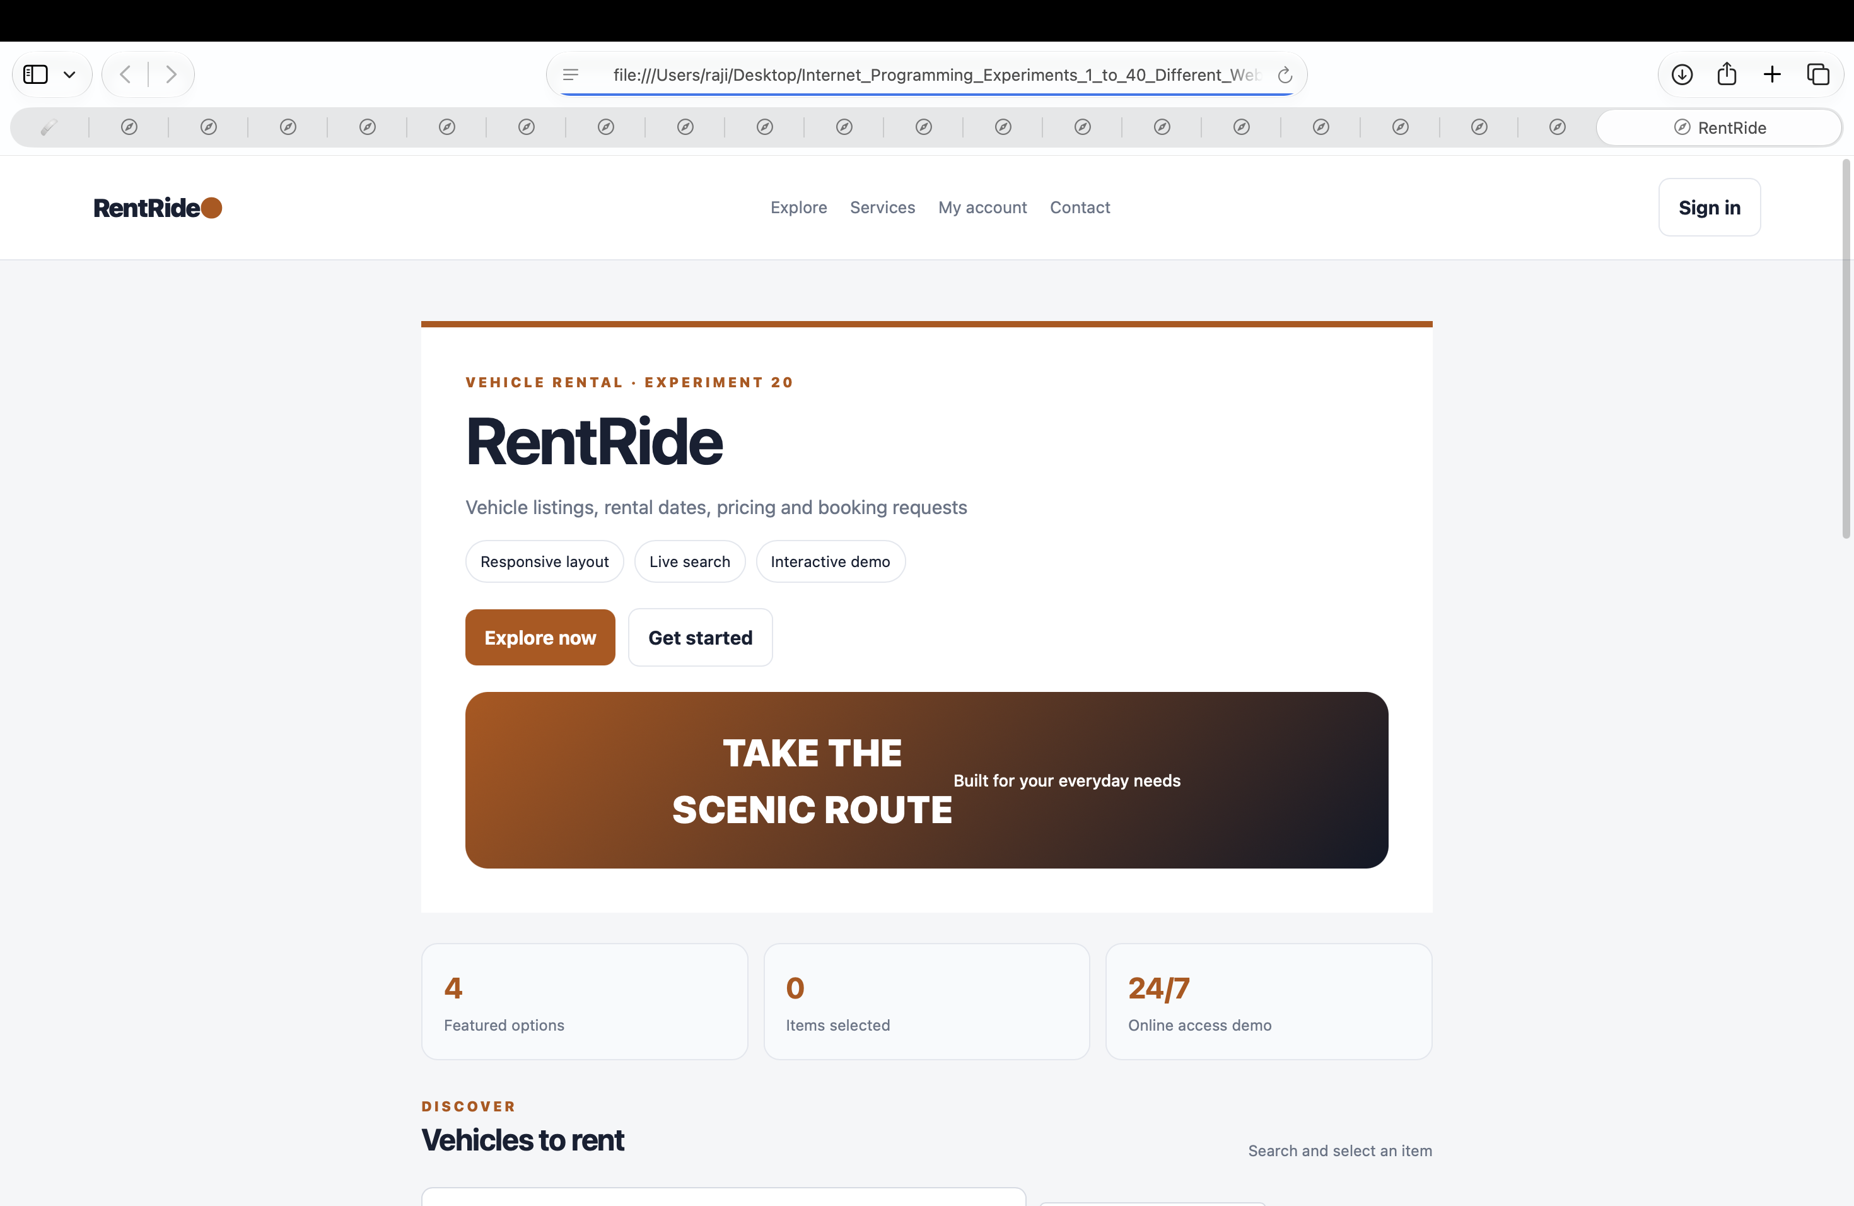
Result: The page runs in a modern browser and displays the sample result when Run Demo is clicked.

